THIN SECTION INSTRUCTIONS

A guide to making petrographic thin sections using the facilities in the Geology Department at Sonoma State University.

By Philip Mooney, David Bero, and Sue Nosker
Spring 2014

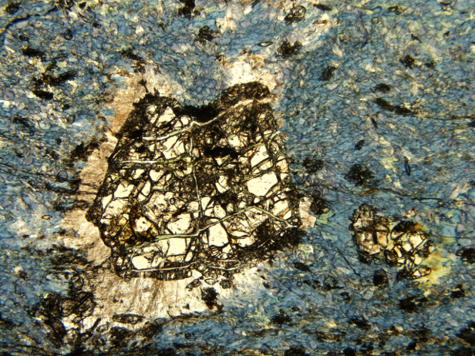

Introduction

Within this guide is a thorough description of how to make thin sections using the facilities at Sonoma State University. Make sure that you read through and understand the following directions before proceeding. Although these instructions will be largely correct for most thin section facilities, each lab will have its own quirks and will likely contain slightly differing supplies. If you are unsure or have questions, ask someone that is knowledgeable about the equipment and procedure. Much of the thin section equipment is delicate, easily damaged, and quite expensive to replace.

The creation of a thin section can be divided into six major stages:

- Cut billet on tile or slab saw
- Prepare billet using lap wheel
- Attach hot billet to glass slide using epoxy
- Trim thin section on trim saw
- Grind thin section on vertical grinder
- Finish thin section
Cutting Billet

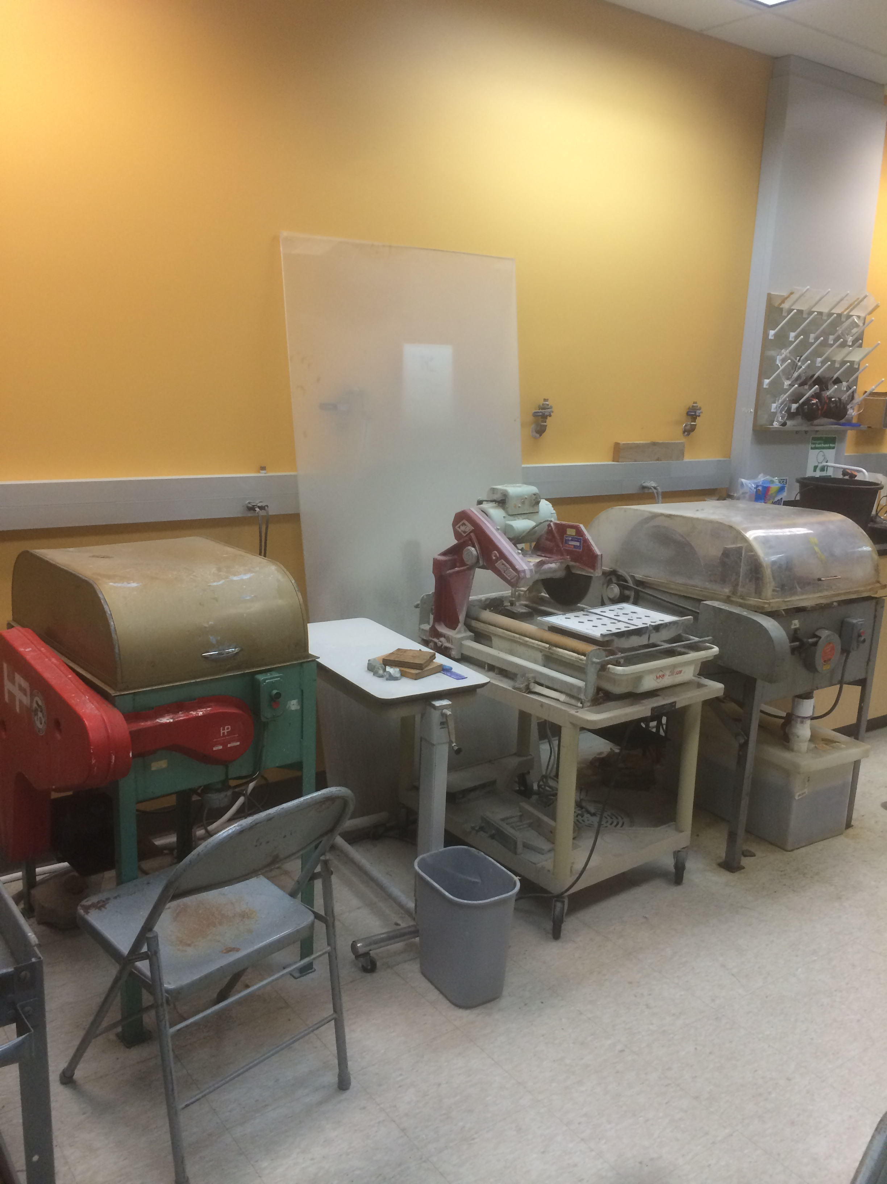
The goal of this step is to take your sample of rock and cut it down to billet that is slightly smaller than a glass slide and ¼-½” thick. The department has three saws downstairs in Room 21, a tile saw, an oil slab saw, and a water slab slaw (Figure 1). Unless you have a particularly large sample to cut, use the tile saw (Figure 2).

Instructions Using Tile Saw
- Label sample.
Figure 1 – From L to R. Oil slab saw, tile saw, water slab saw.
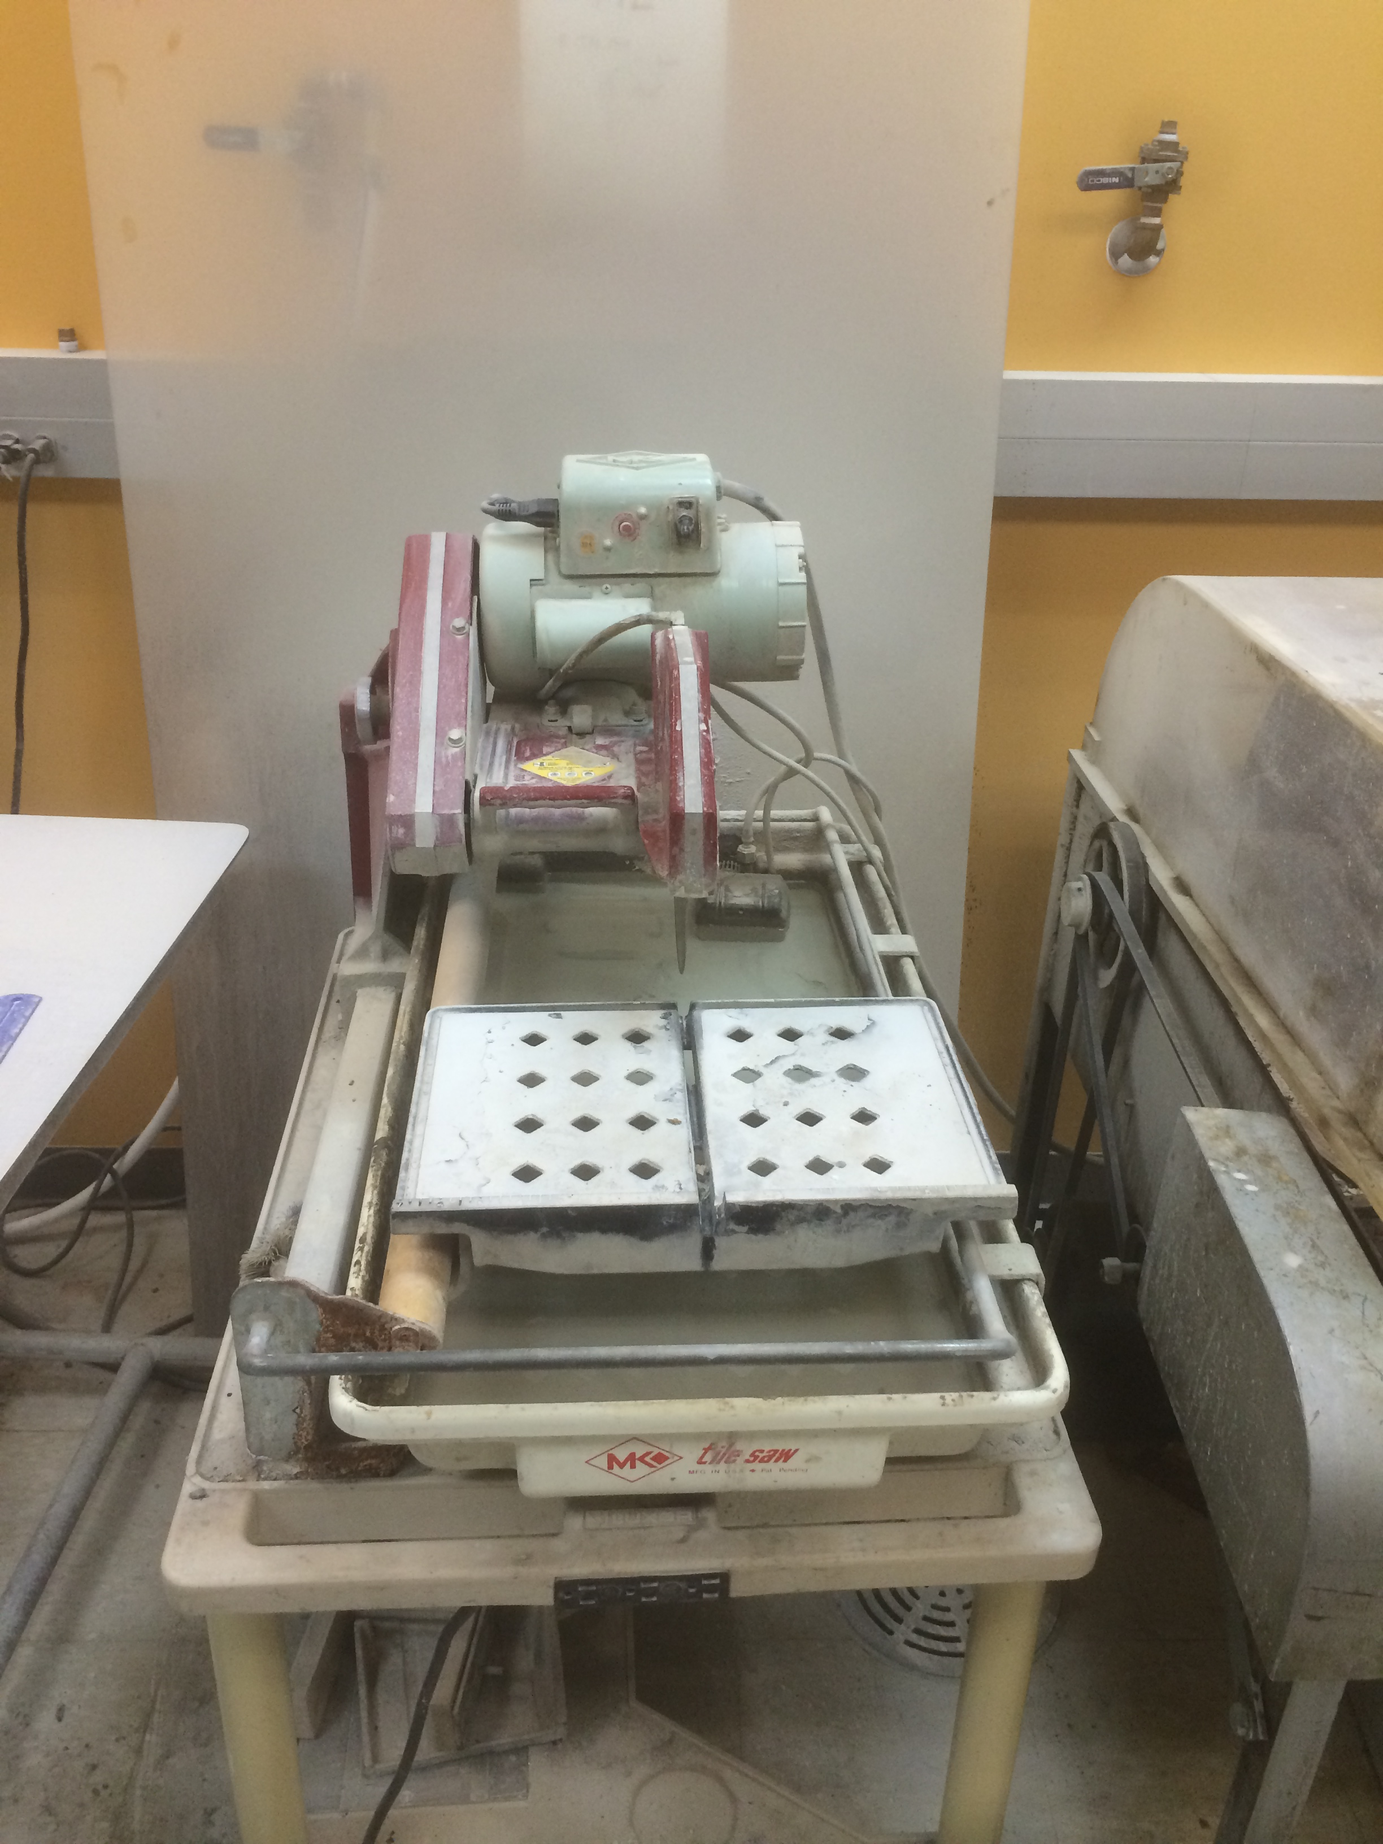
- Decide where you want to cut the rock. Remember that the orientation of the cut with an anisotropic rock will show the rock fabric differently.
Figure 2 – Tile Saw
- Make sure there is sufficient water in tray so that the intake of the pump is submerged. If not, fill the tray with tap water.
- Put on safety glasses and use ear protection. Turn on power using the switch on top of the machine (Figure 3).
- Check to see that water is being sprayed abundantly onto the saw blade before cutting begins. If not, fill the tray with tap water.
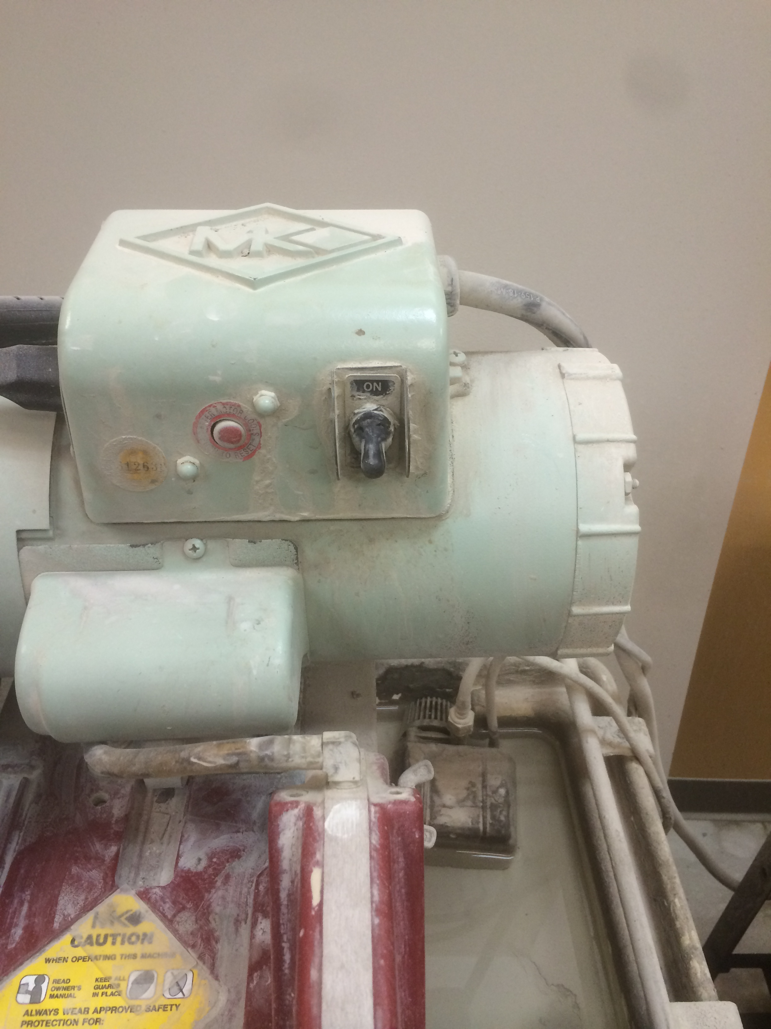
- Make two parallel cuts through the rock forming a ¼-½” thick slab. Hold the rock firmly and cut slowly in a straight line. Do not use excessive force while pushing the blade toward the sample but rather let the blade do the cutting at its own pace using minimum force (Figure 4)
Figure 3 – On/Off
- Using a glass slide or cover slip, mark off the area that you would like to see in thin section. This will be the outline of your billet.
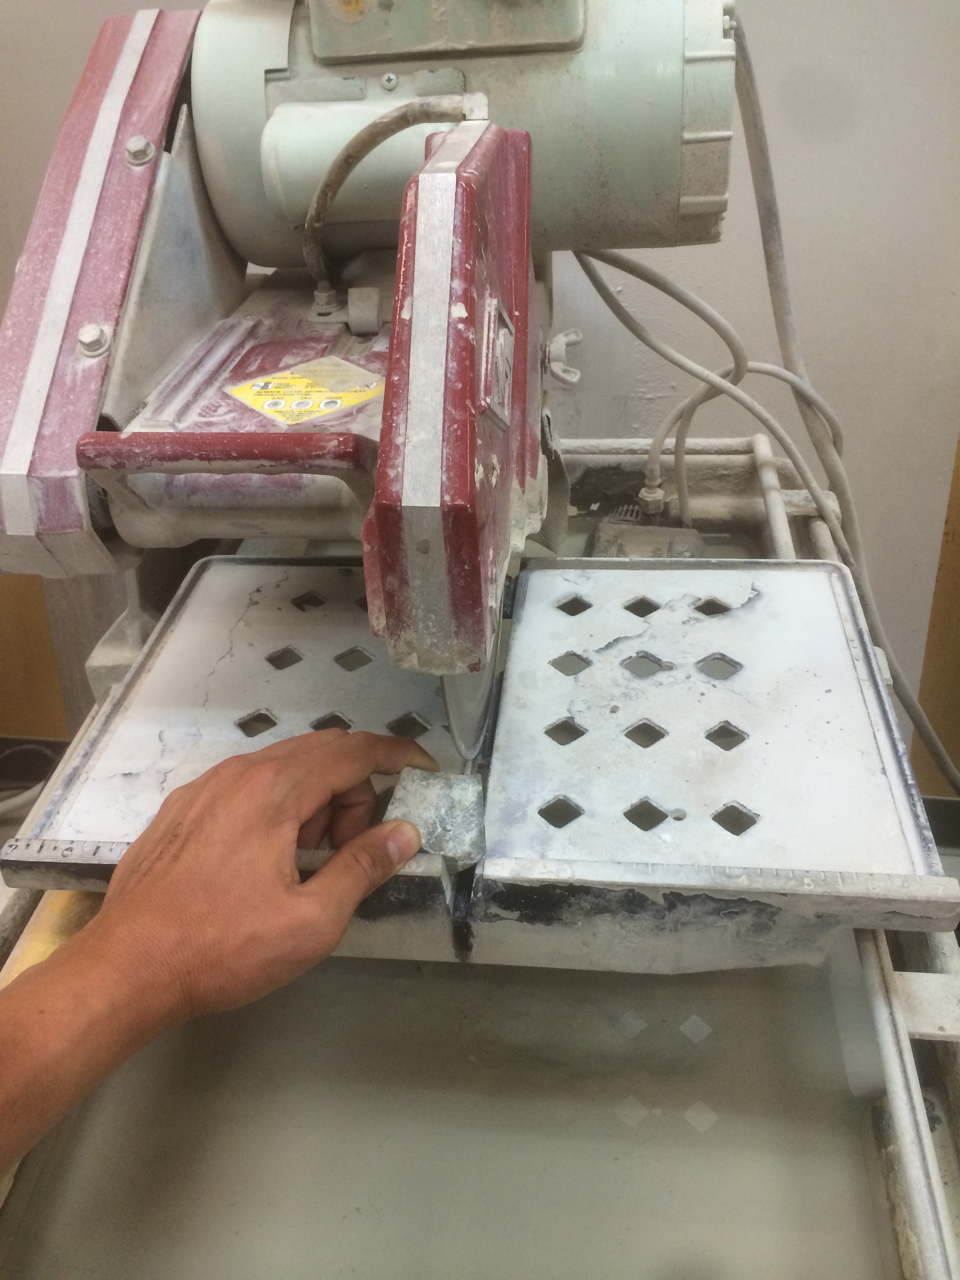
- Align one side of your marked area with the blade, and slowly push the slab into the blade to make your cut. Complete the other three cuts to complete the cutting of the billet. Your final billet should be slightly smaller than a glass side and ¼-½” thick.
- Label the billet with the sample number.
- Clean up all rock fragments left on the tile saw.

Figure 4 – Cutting a billet
Cutting Billet (Page 2)
Instructions Using Slab Saws
- Label your sample.
- Decide where you want to cut the rock. Remember that the orientation of the cut with an anisotropic rock will show the rock fabric differently.
- Open the cover to the slab saw and lock sample in the vise. To do this, move to the closest notch and screw the vise in tight.
- Check to make sure the surface of your rock that is fed into the blade is perpendicular. Attempting to cut a beveled edge will break the saw blade.
- Check the pull chain setting to ensure the saw will turn off after your cut.
- Position rock ¼” from blade. use side crank to position sample so you can make two parallel cuts about ¼-½” apart.
- Pull up red handle. Make sure the carriage threads engage the threaded rod.
- Close lid and push red button to turn saw on. Do not turn on the switch when the lid is up and do not lift the lid while the saw is running. This is dangerous and will make a mess.
- Once slab is created, use the tile saw to cut your billet. See instructions above.

Preparing Billet

The goal of this step is to prepare the billet by using the lap wheels to polish the face that will be attached to the glass slide. This is done using the lap wheels in the Thin Section and Fine Rock Laboratory, Darwin 129.

Instructions
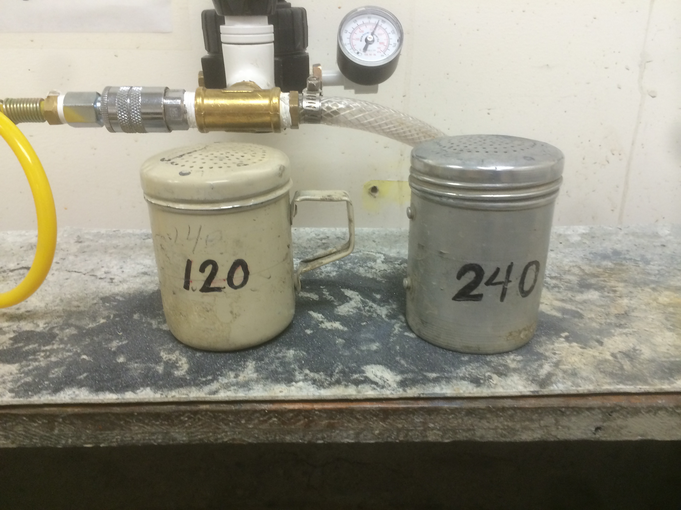
- Check to make sure your billet is labeled with the sample number on top.
- There are two lap wheels in the room. We will start using the wheel on the left for the 120 and 240 grits (Figure 5). We will then use the wheel on the right for the 400 and 600 grits.
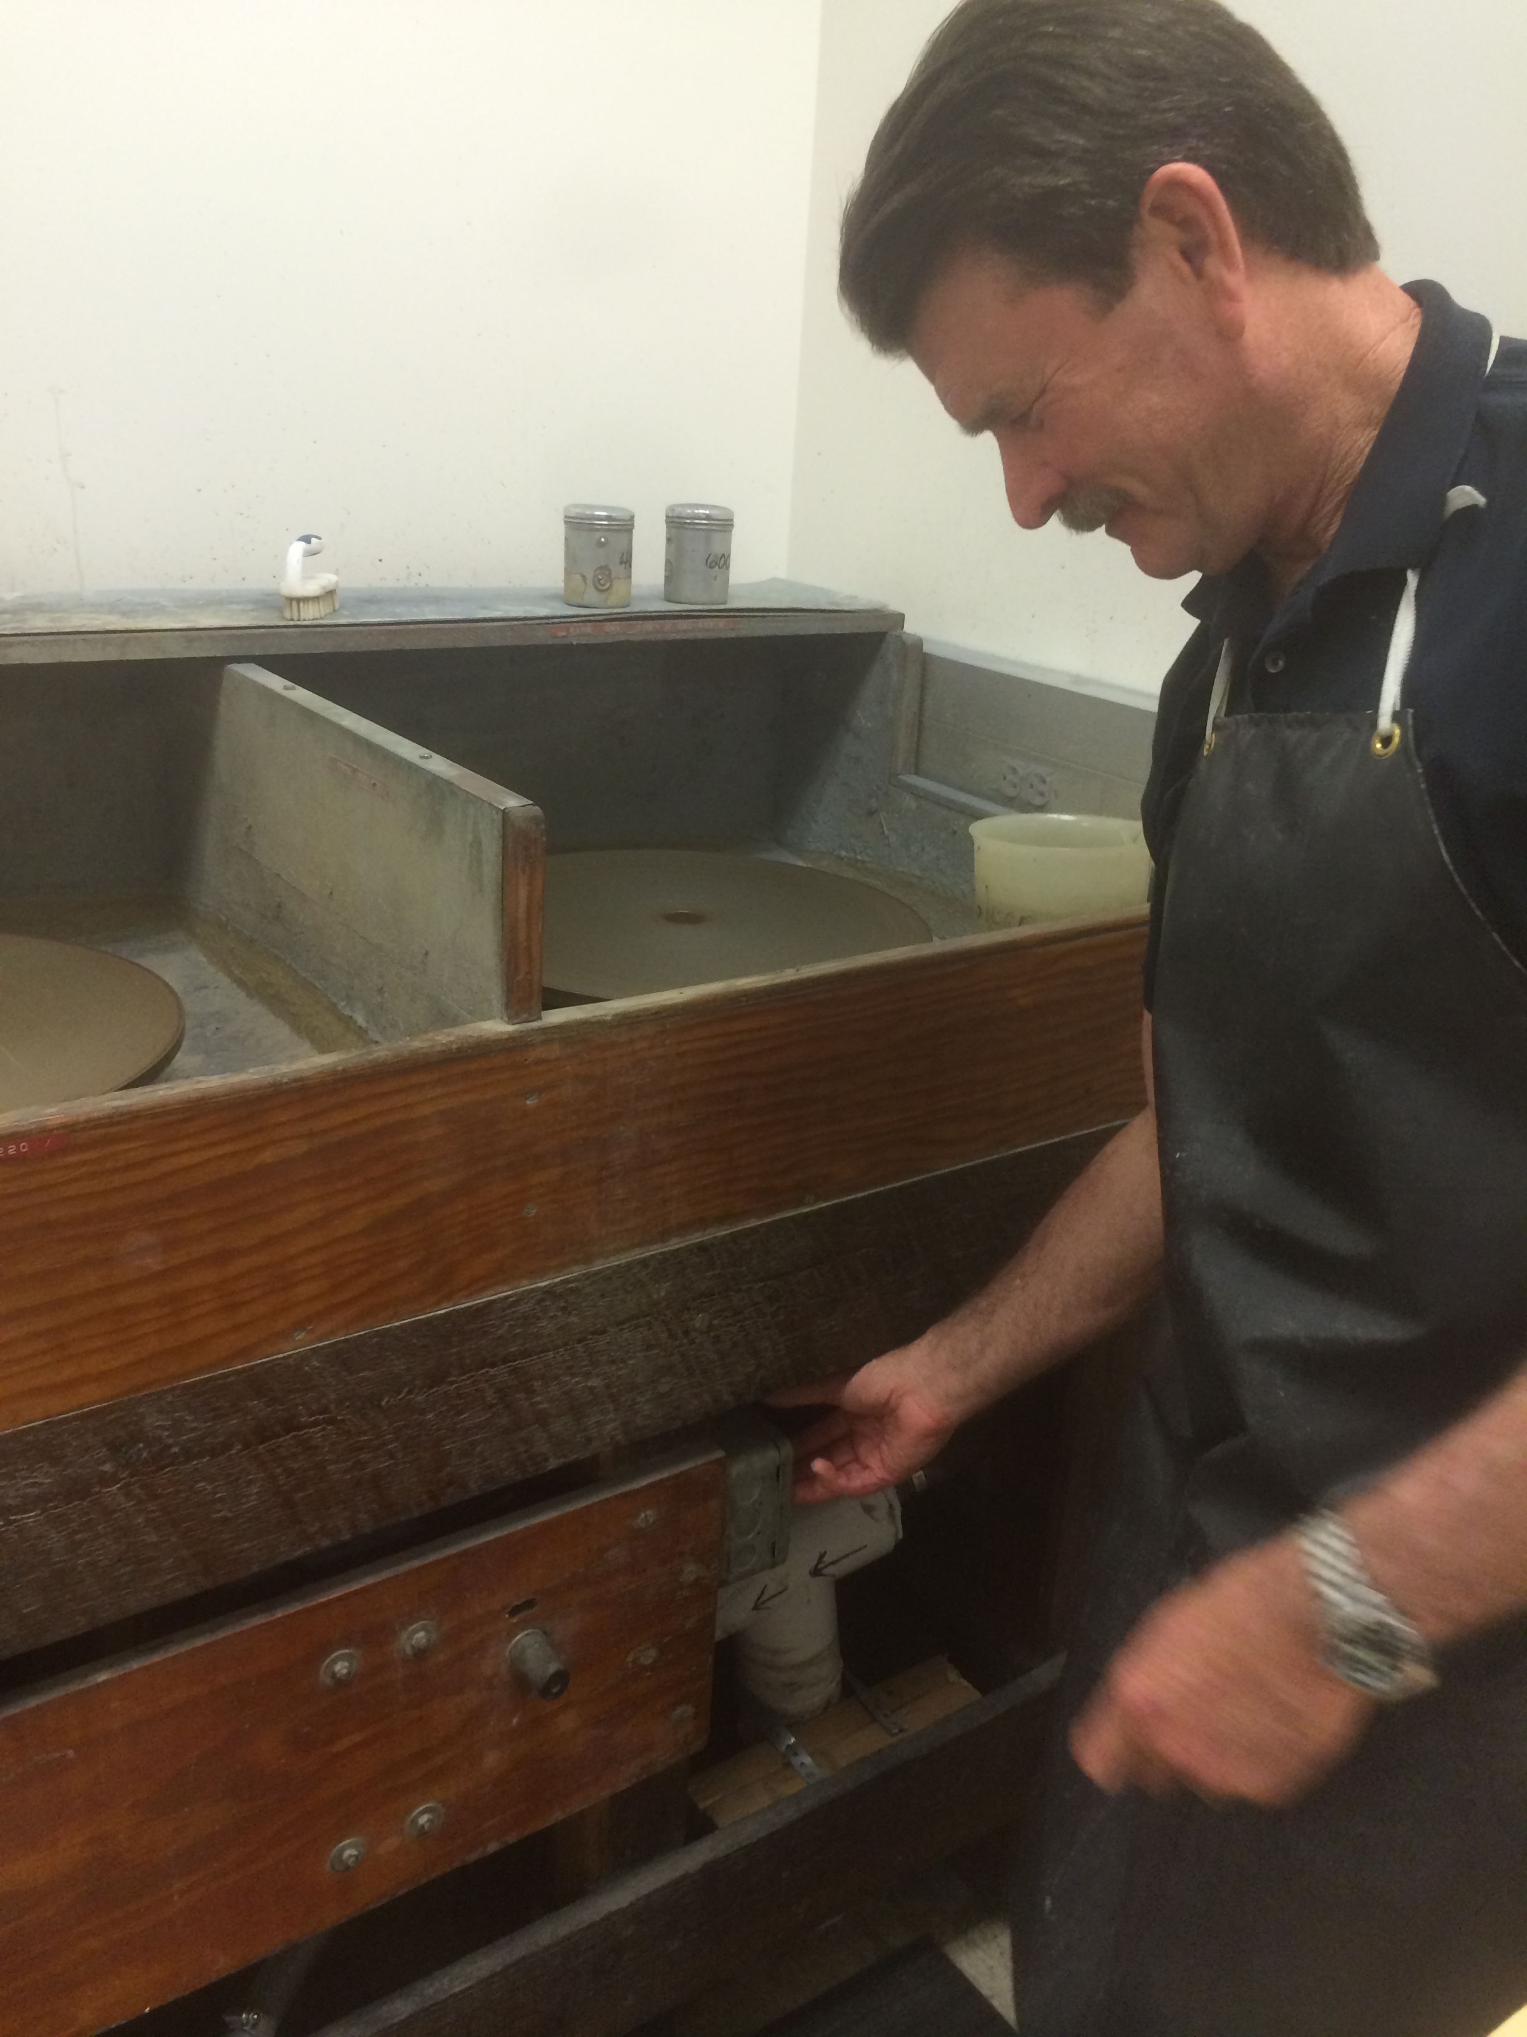
- Make a slurry of grit on the left lap wheel using ~6 shakes (about a teaspoon) of 120 grit and a small amount of water. The grit is contained in shakers on the small shelf just above the lap wheels and there is a pitcher of clean water next to the lap wheel.
Figure 5 – Grit Shakers
Figure 6 – Location of On/Off switch
- Turn on the lap wheel using switch at hip level below the machine. It looks like a light switch with two options, one for each wheel (Figure 6).
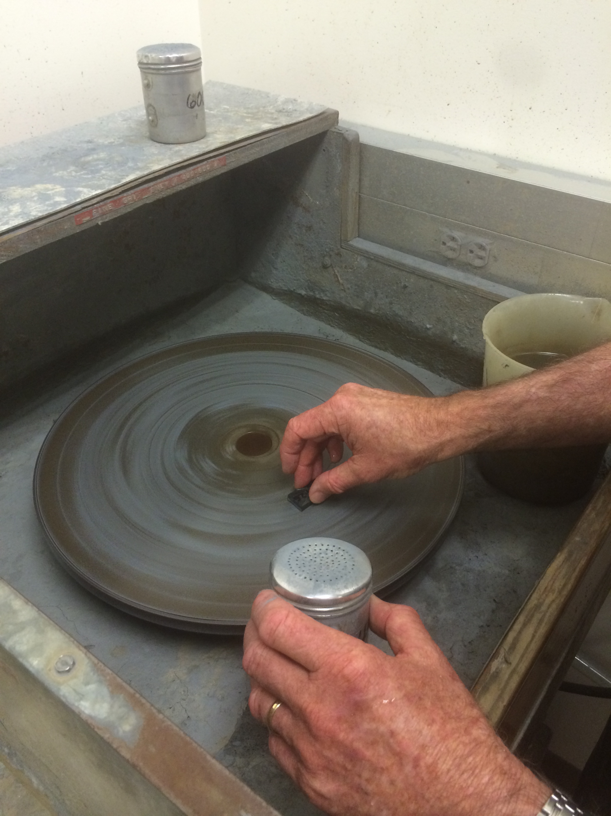
- Slide the billet back and forth (50-100 times) in the slurry to grind away the saw marks and the damaged surface. The downward pressure should be evenly spaced across the billet and consist of the weight of your hand (Figure 7). Use the entire surface of the lap wheel to avoid grinding the wheel down in one spot. When the slurry gets dry, add some more water. Check the quality and flatness of the billet by cleaning and drying the chip and checking the reflection by holding it at a small angle to the light. Continue grinding until the ship is flat and smooth.
Figure 7 - Polishing
- Repeat these steps with the 240, 400, and 600 grits. Remember to use the right-hand wheel for the 400 and 600 grits. Once you have obtained a flat, smooth, and reflective surface, the billet is done.
- Wash billet with water and a tooth brush when finished.
- Clean both lap wheels with water and a brush. Let them spin until they are completely dry.
- Dab billet with kim wipe to dry off.

Attach Prepared Billet to Glass Slide

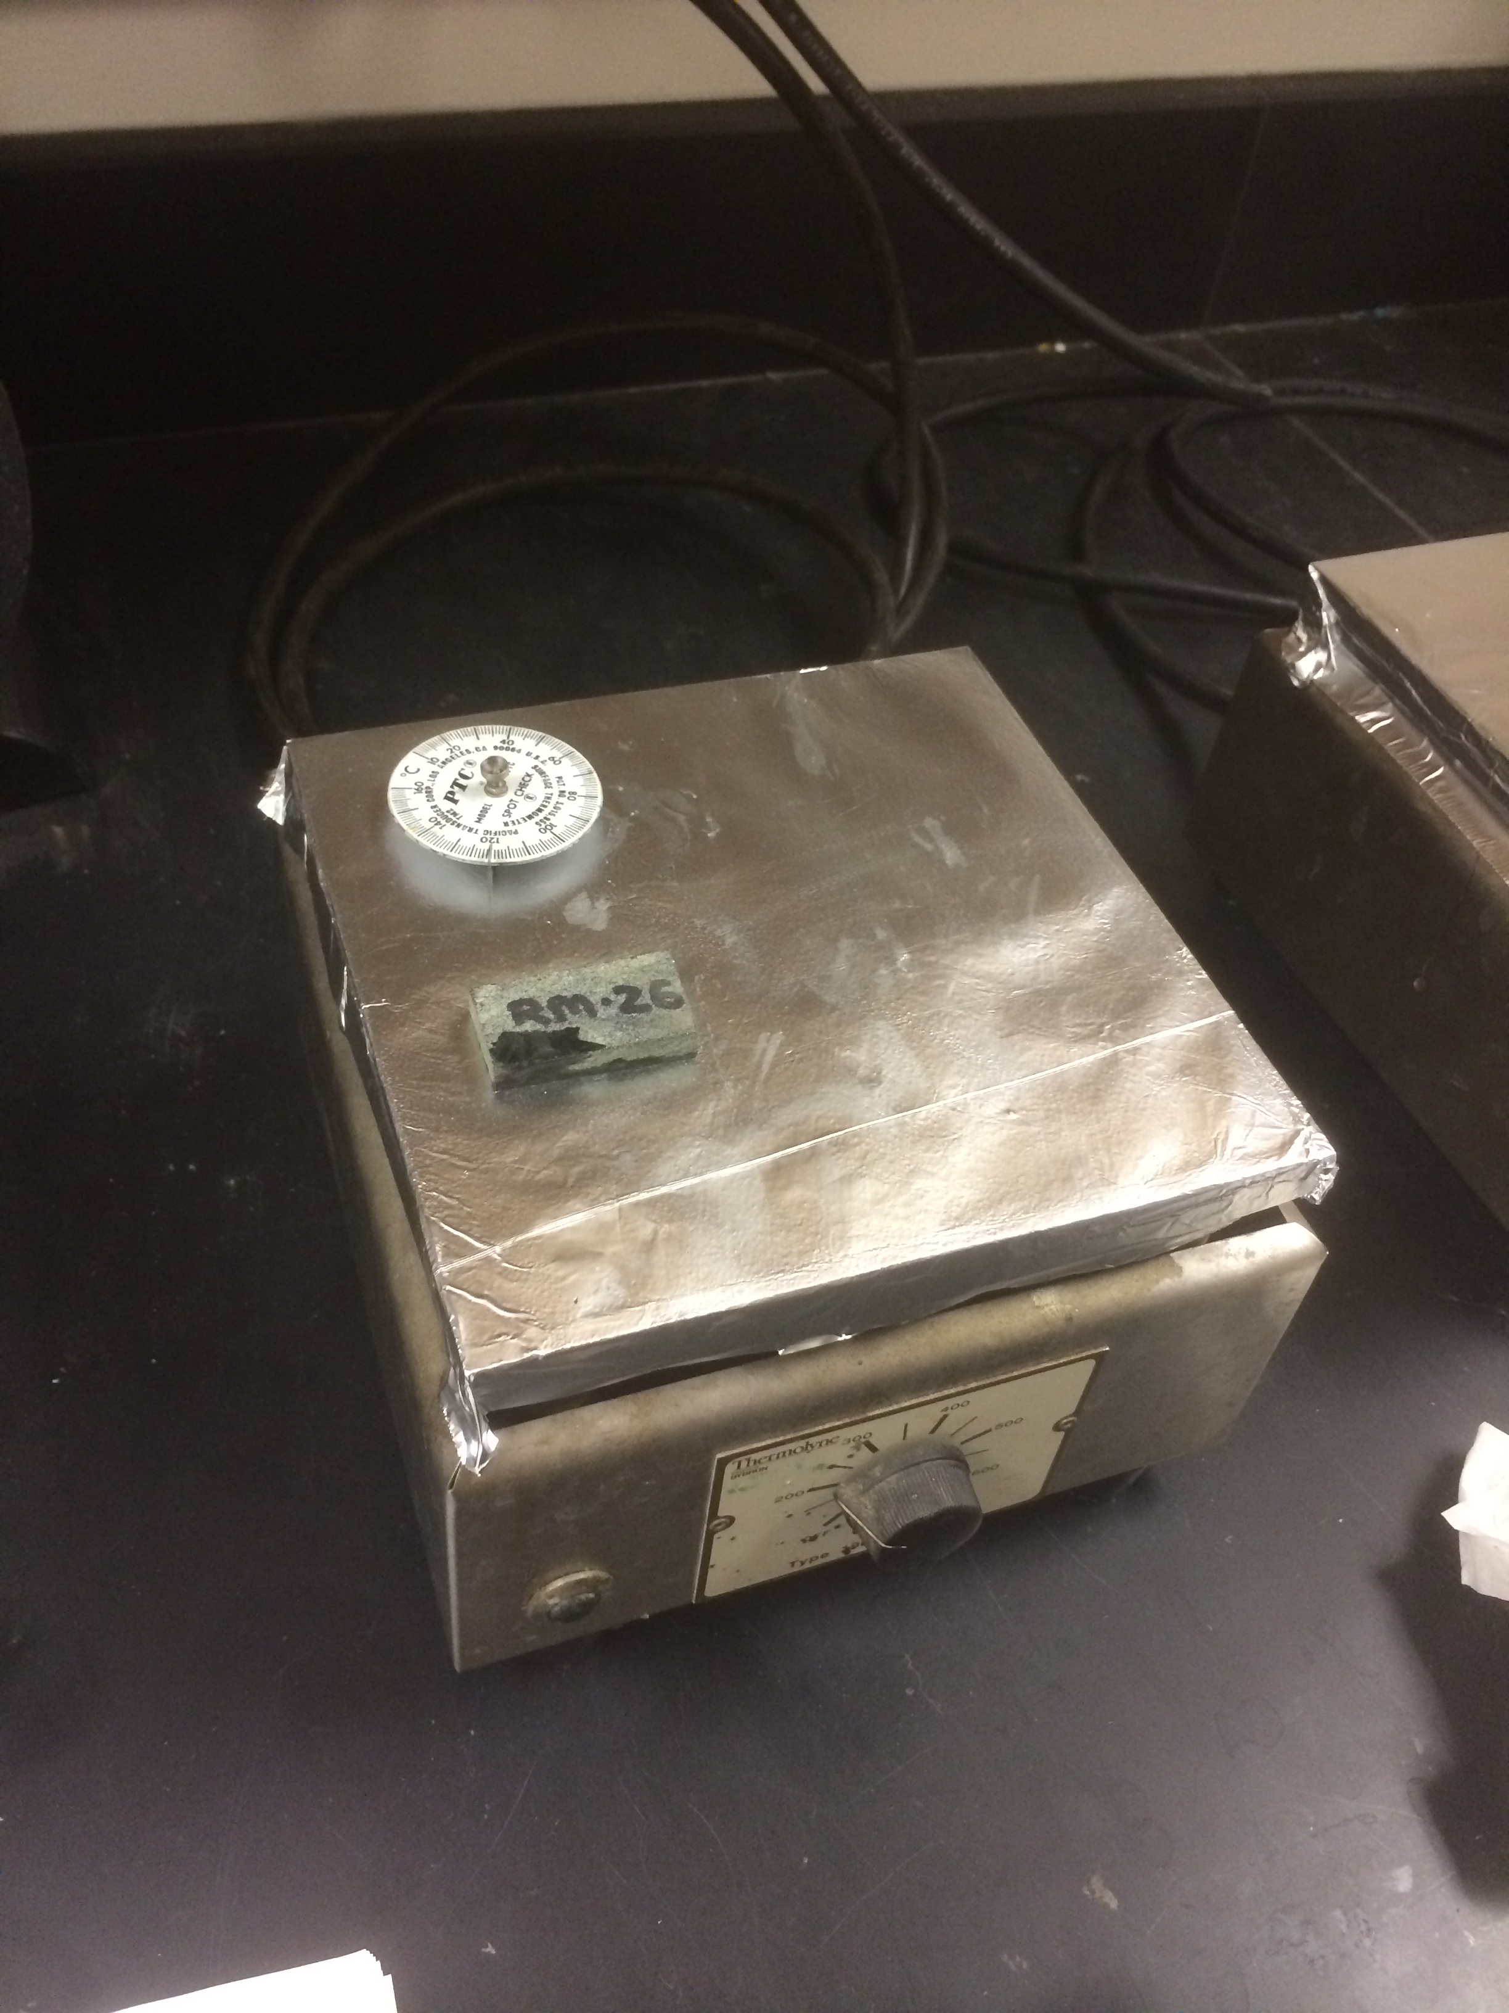
The goal of this step is to use epoxy to securely attach the polished face of the billet to a clean glass slide. This work will be done in the Thin Section and Fine Rock Laboratory, Darwin 129.

Instructions
- Cover the hot plate with aluminum foil if needed (Figure 8).
Figure 8 - Hot plate with aluminum foil
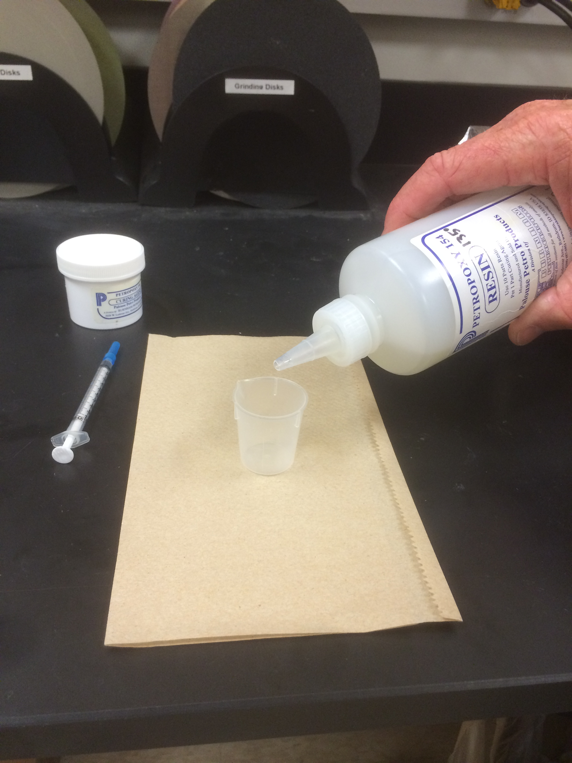
- Plug in hot plate and set to 120–130°C. Give the hot plate plenty of time (15-30 minutes) to equilibrate. Set billet on the hot plate for 30 minutes, making sure the polished surface is facing down.
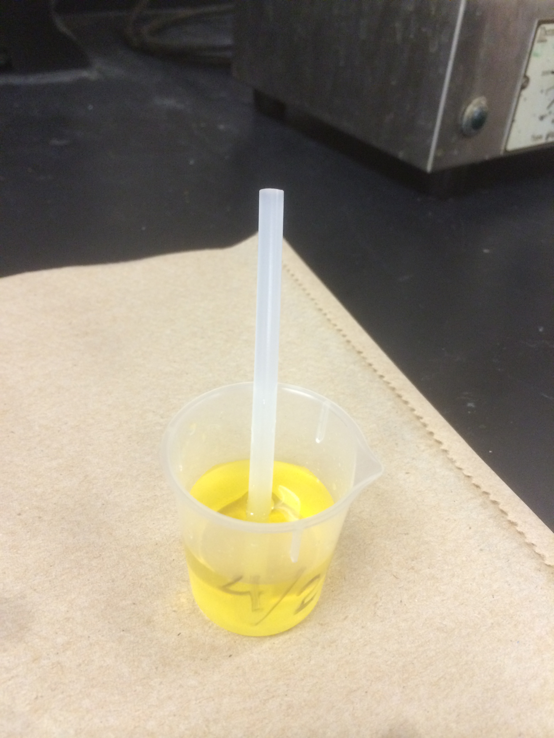
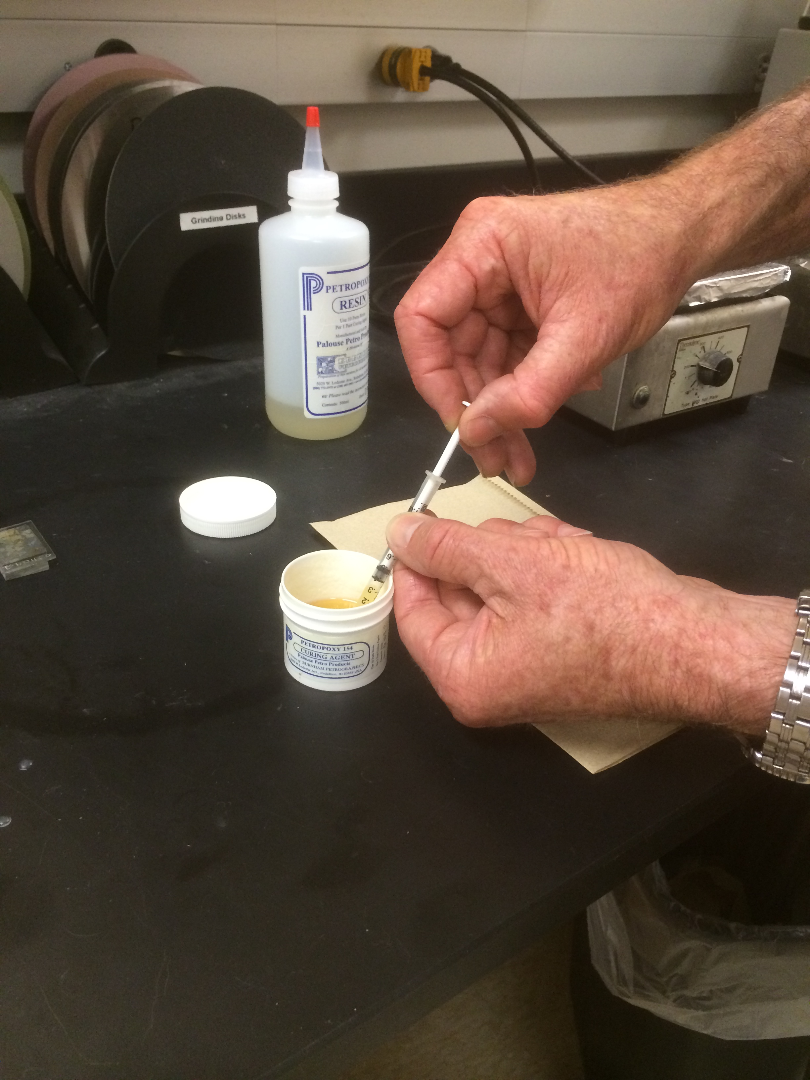
- Mix up a batch of epoxy in a 15mL plastic cup (Figure 9). The type of epoxy we use is Petropoxy and there are two parts: the epoxy (in large clear plastic bottle) and the curing agent (in the small white plastic jar). Pour 10 mL of epoxy in the plastic cup using the volume marks on the side of the cup as a guide. Using a 1.0 mL syringe, add 1 mL of curing agent. Clean the syringe, cap it, and reuse it. Use a plastic stirring rod and thoroughly stir the mixture. This will take a few minutes. Leave the plastic stir rod in the plastic cup when finished and let the mixture sit an hour to make sure the bubbles come out of the epoxy. When complete, there should be no bubbles and the epoxy should be the consistency of warm honey (Figure 11).
Figure 9 - Petropoxy
Figure 10 – Adding curing agent
- Take a clean glass slide out of box. The slides are frosted slides, meaning one side is scuffed and one side is smooth. You will be mounting the billet to the frosted side of the slide. Make sure not to touch the slides with your fingers, especially the surface that will receive the epoxy. Clean the slide with alcohol and let it dry.
Figure 11 – Epoxy without bubbles
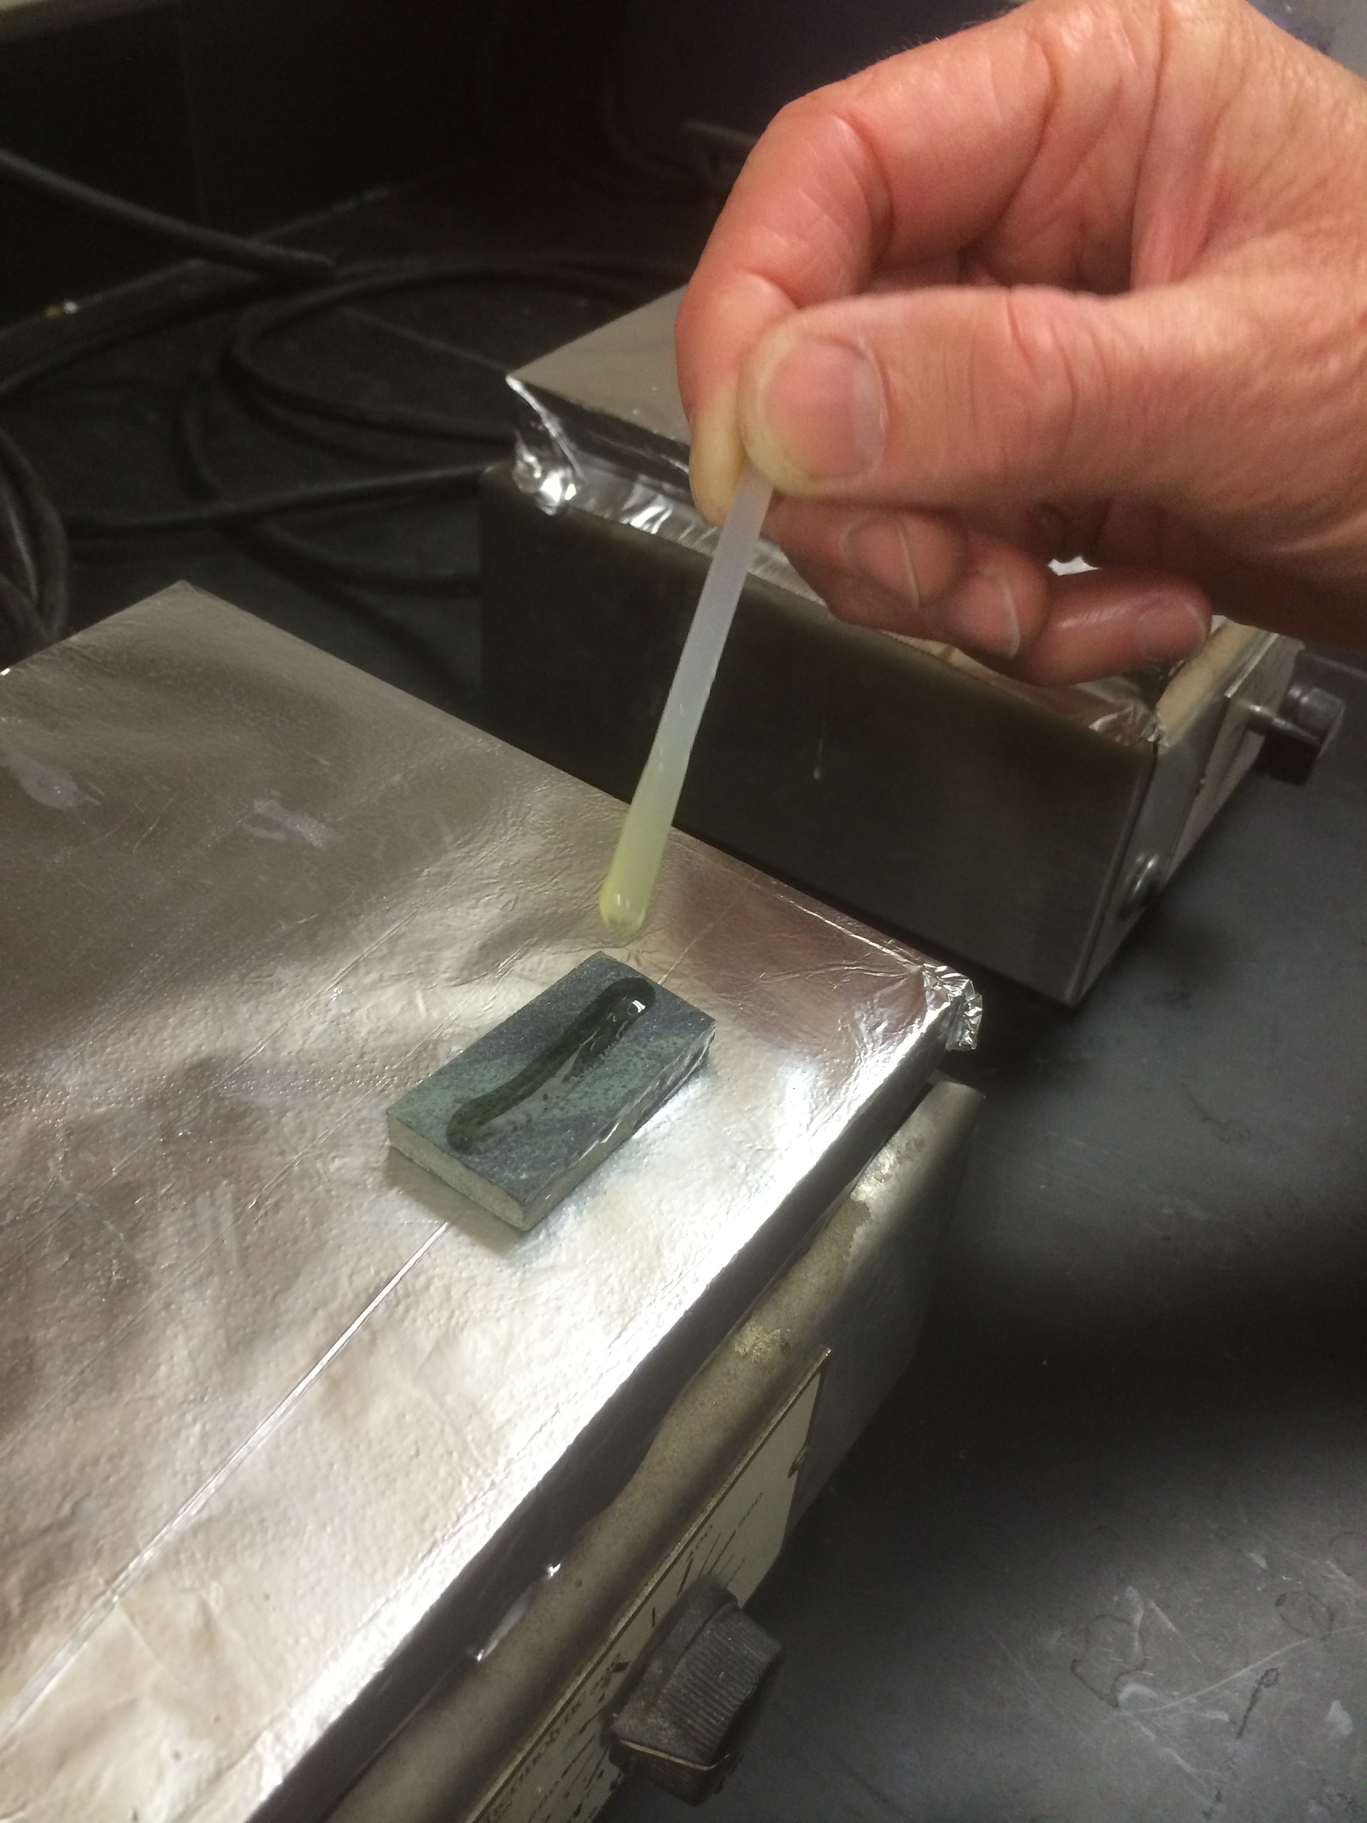
- Use a diamond scribe to etch the sample name and number on the back (the shiny side of the glass slide, opposite the side where the rock is mounted) of the slide under the wide area of glass at one end.
Figure 12 – Apply epoxy to sample
- Using the stir rod, apply a line of epoxy the width of the stir rod to the surface of the billet that is to be glued (Figure 12).
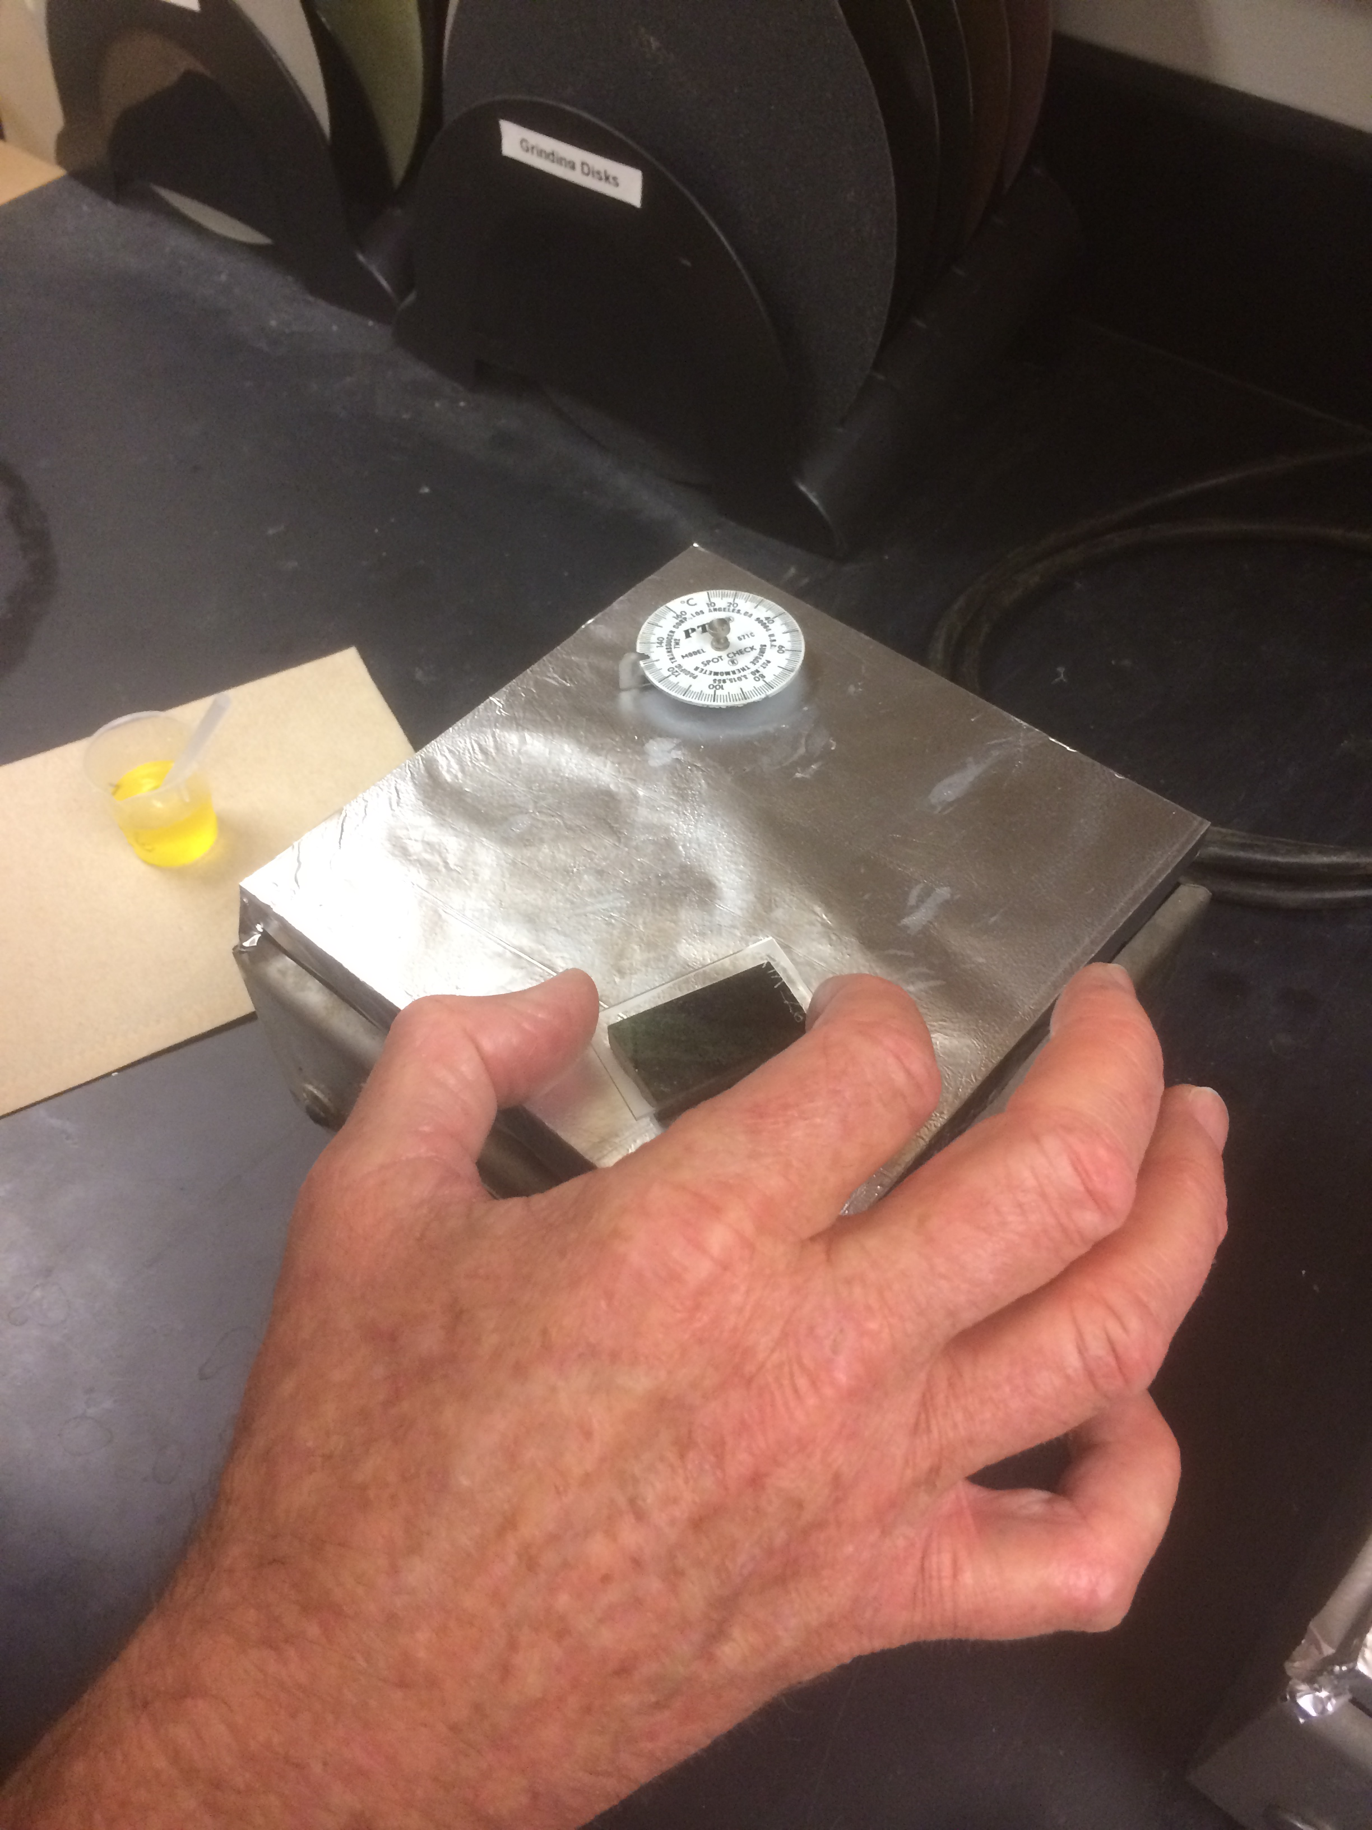
- Let down entire glass slide onto the polished billet surface. Move the slide around to even out epoxy and eliminate bubbles. Let sit on hot plate for 30 minutes (Figure 13).
Figure 13 – Slide around to remove bubbles
- Take the billet and slide off the hot plate using paper towels or gloves to insulate your hands. Turn off hot plate and let the thin section sit and cool off for an hour.
Trimming Thin Section

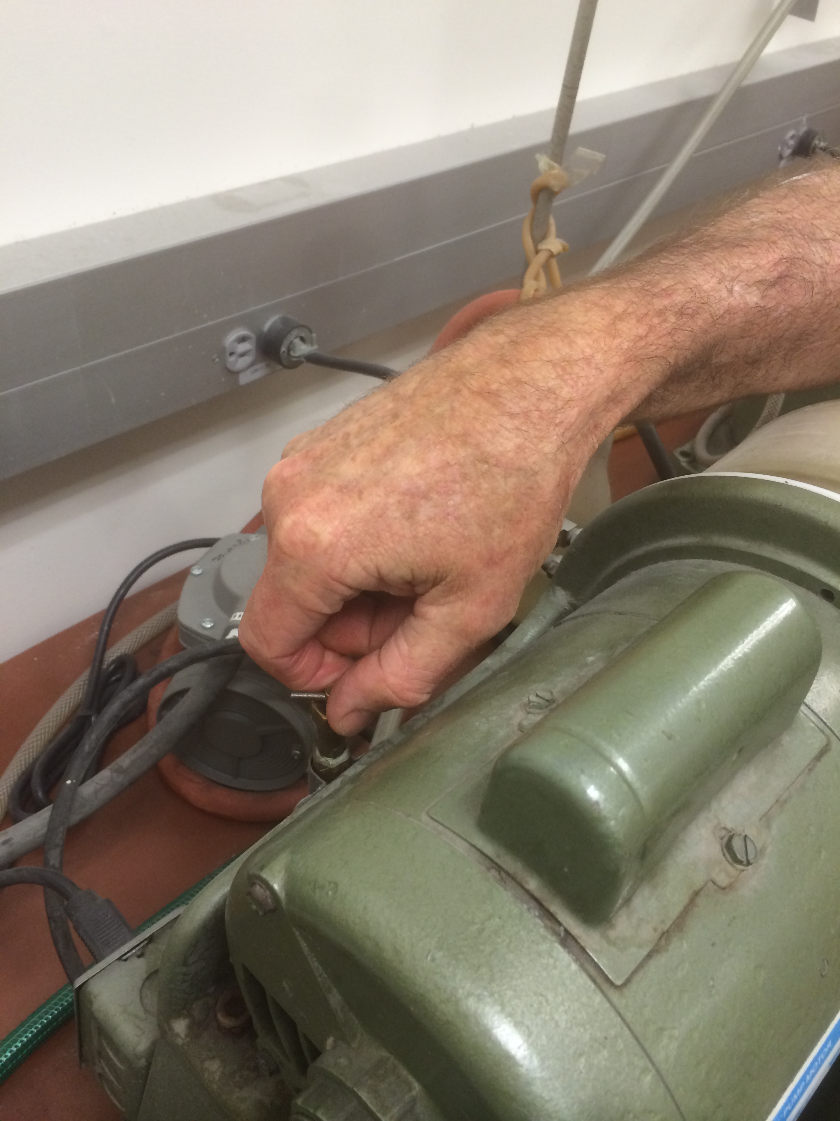
In this step, we will use the trim saw to remove 90% of the excess rock from your thin section. This work will be done in the Thin Section and Fine Rock Laboratory, Darwin 129.

Instructions
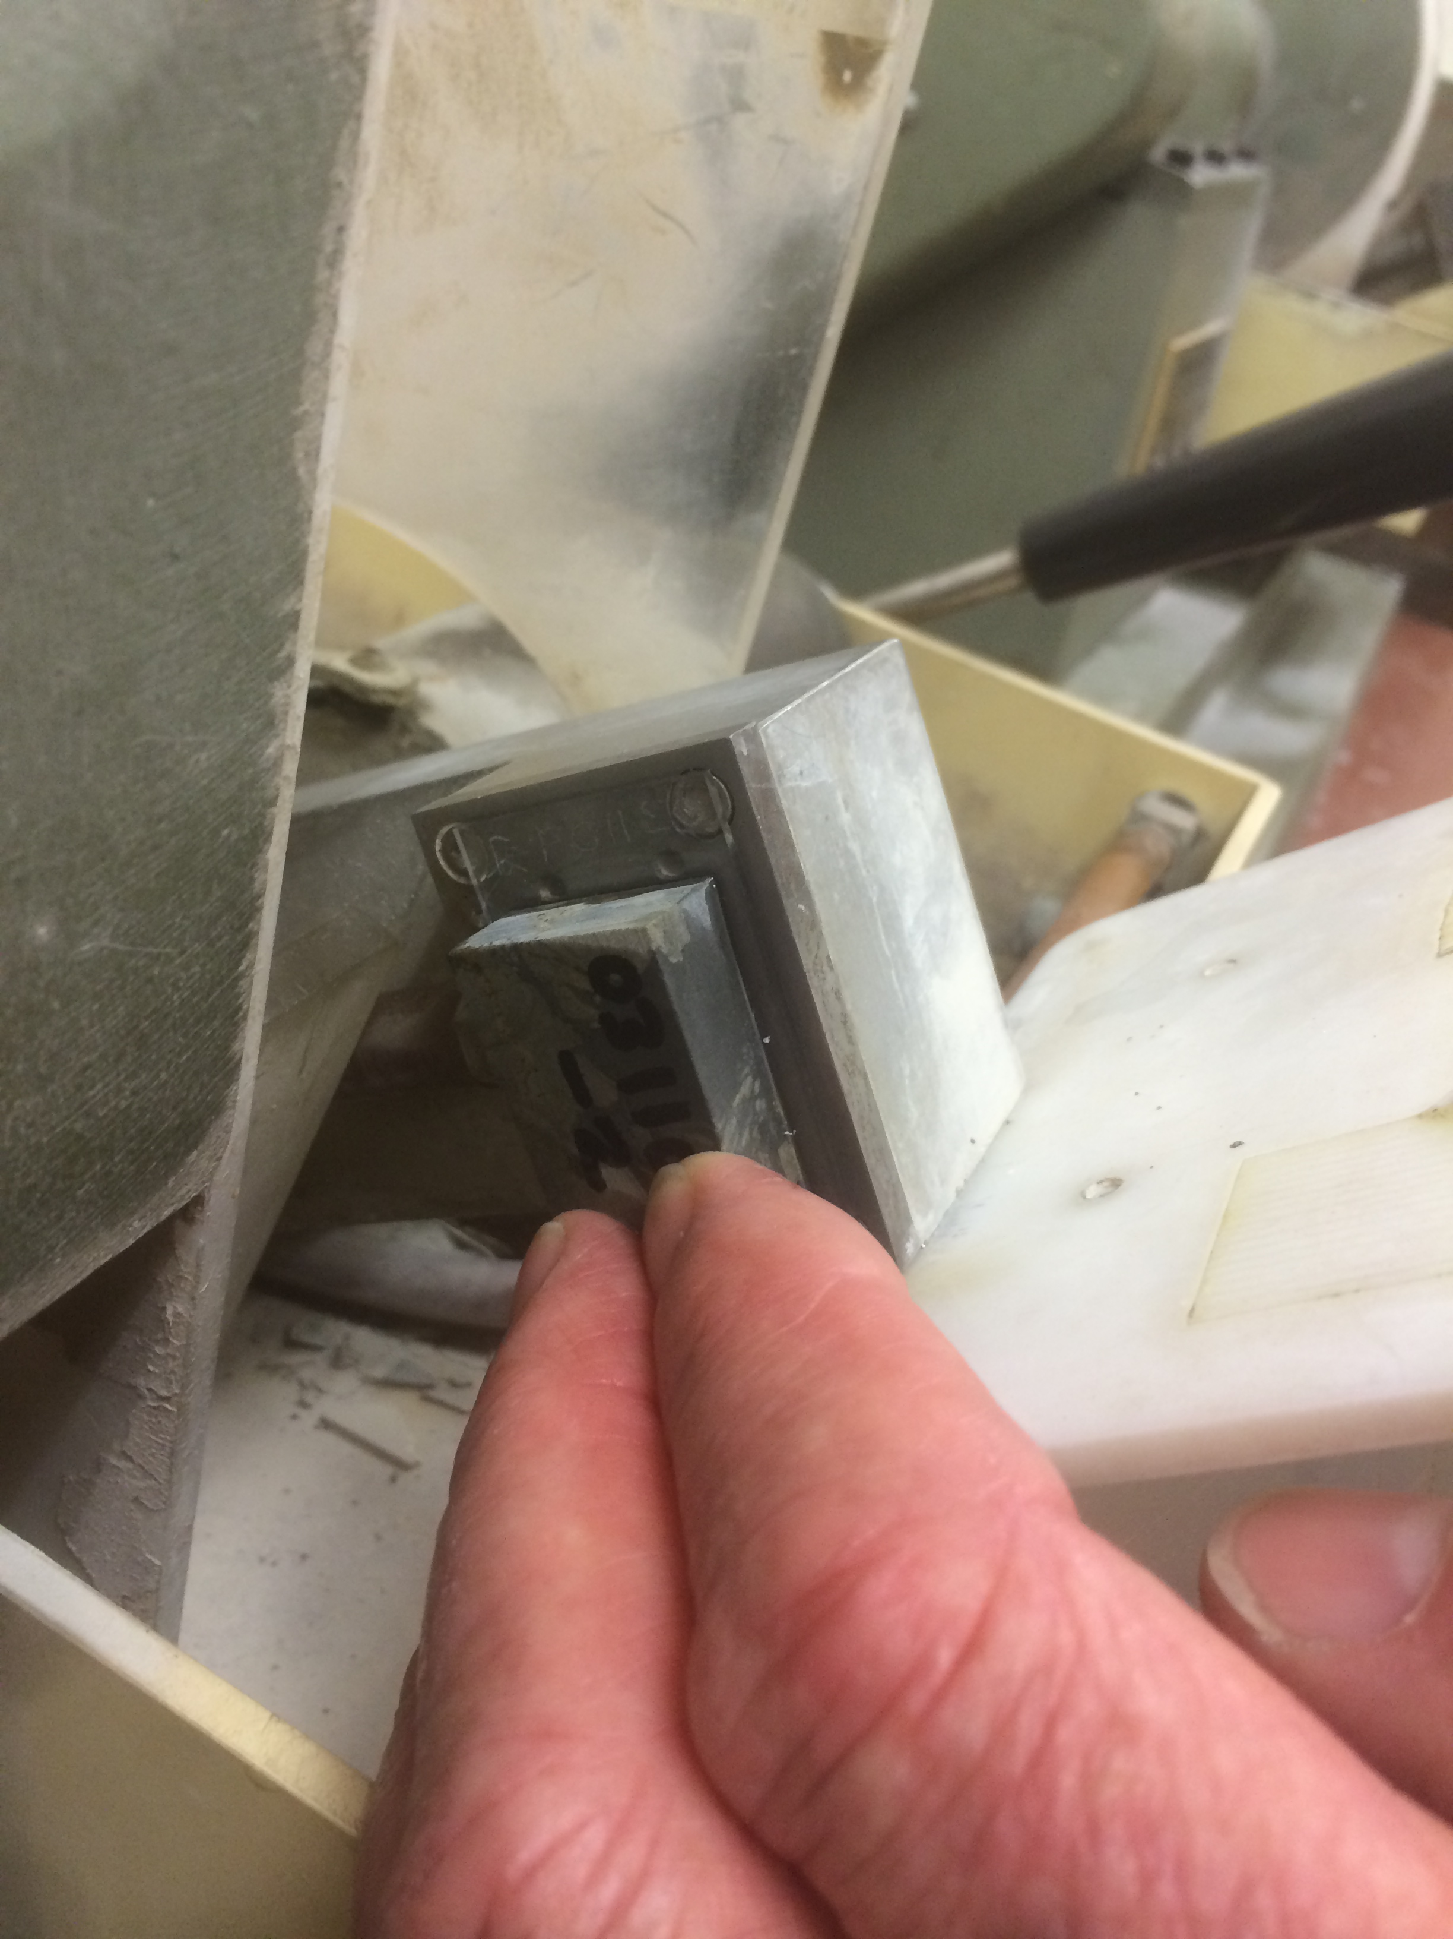
- Turn on water using the valve on the back of the machine (it will require ¼ turn clockwise) and adjust the volume of slow so there is ample water flowing on both sides of the trim saw blade (Figure 14).
Figure 14 – Water On/Off switch
- Place thin section on the trim saw (Figure 15). Then place a clean and blank thin section slide on the vacuum chuck face of the thin section grinder (Figure 16). This will create the vacuum that holds the slide. To make a better seal, wet the slides.
- Put on headphones because the next few steps are noisy. Turn on the vacuum using the switch on the front of the machine. Make sure there is a good seal. Then turn on motor using the other switch on the front of the machine
Figure 15 – Thin section on trim saw
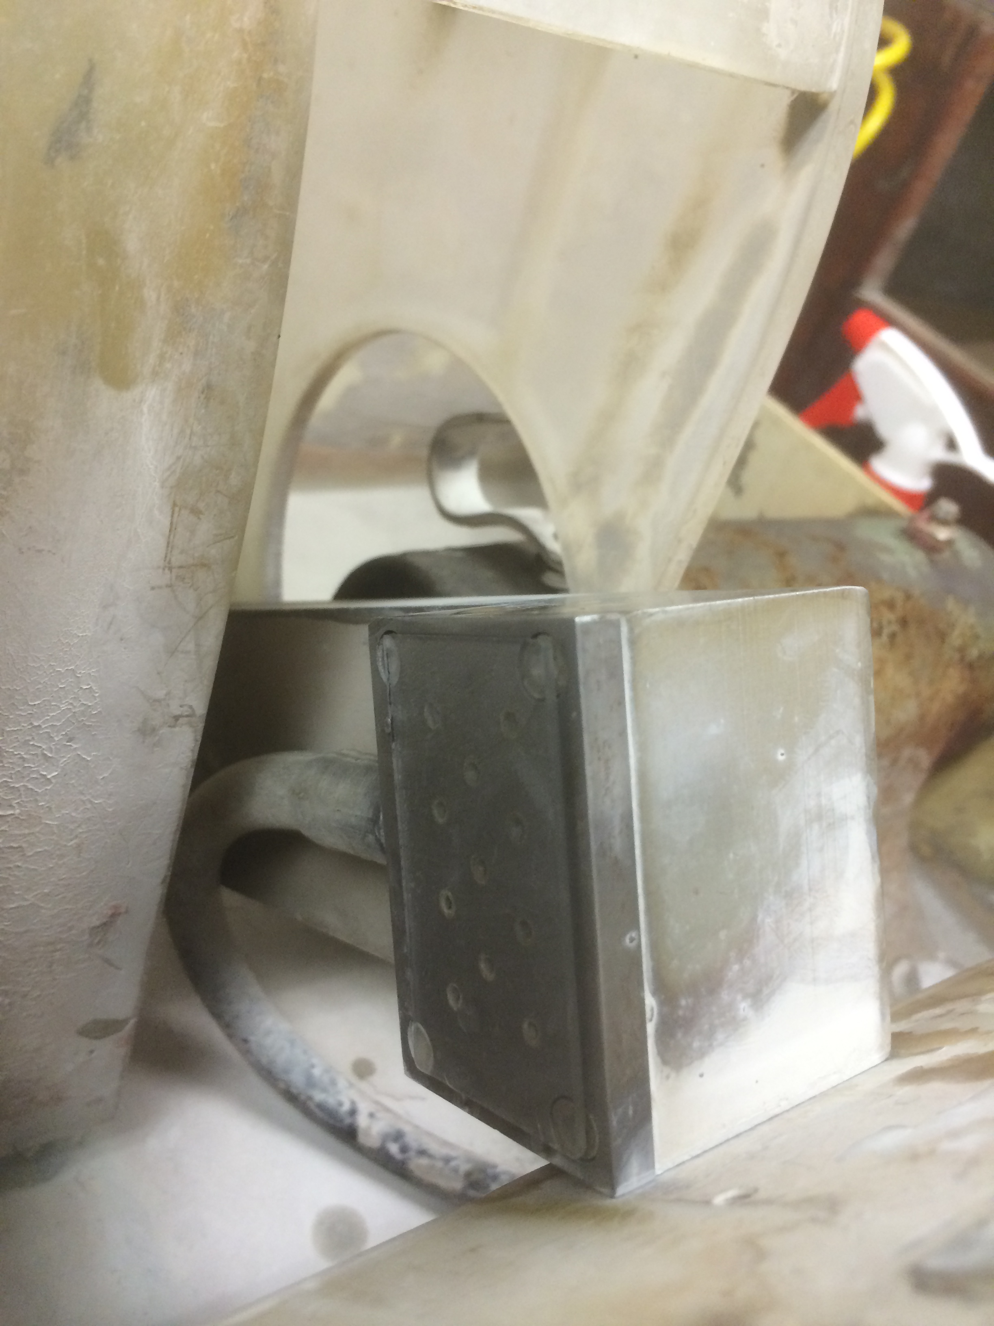
- Bring the lateral position adjustment knob to about 1/16” on slide. When at the correct position, the knob should read “20”. There is a red mark of nail polish marking this position. Use the handle to slowly cut off excess rock from billet, leaving approximately 1/16” of sample on the slide. Push the handle slowly and with moderate and even pressure, moving the chuck toward the blade to cut off the chip. Ease off on the pressure near the end of the cut to ensure you don’t break an edge.
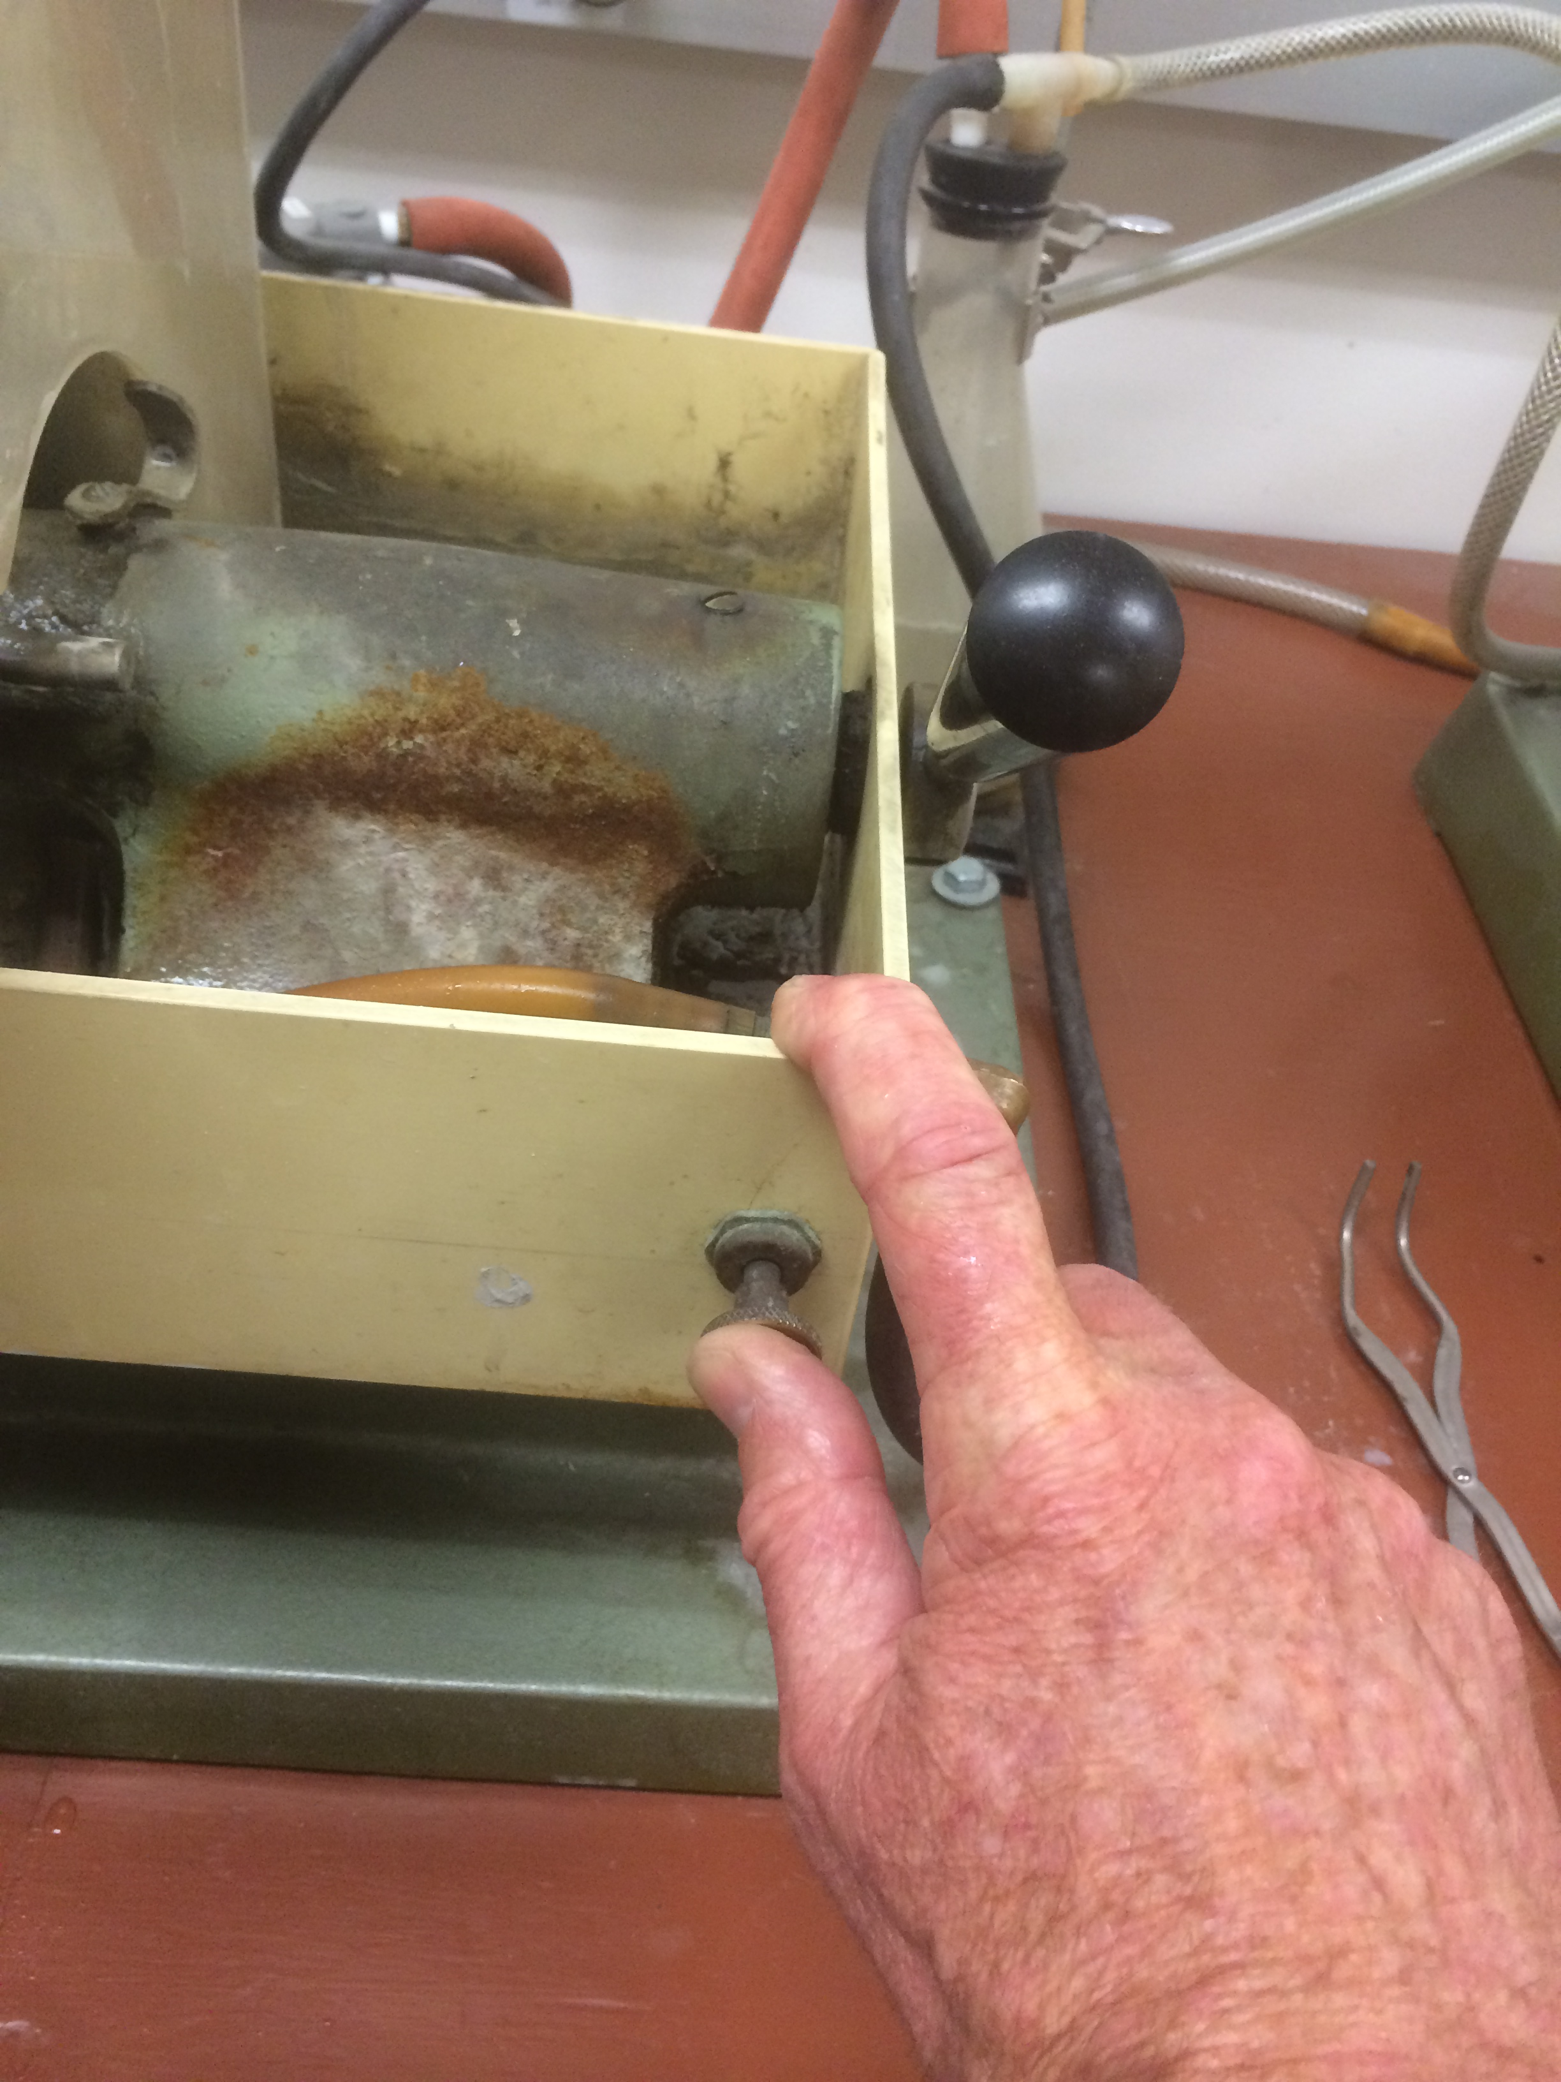
- When finished turn off the vacuum. Press the vacuum release button (Figure 17) and pull trimmed piece out of catch box. Save the billet in case first run is lost or for future additional thin sections. Be sure to label the left over billet.
Figure 16 – Blank slide on grinder

Grinding Thin Section
Figure 17 – Vacuum release button

In this step, we will use the vertical grinder to remove nearly all the excess material from the thin section. This work will be done in the Thin Section and Fine Rock Laboratory, Darwin 129. Expect the grinding process to take 15-20 minutes. Do not hurry this step as you can easily damage your thin section as well as the lab equipment.

Instructions
- Turn water on.
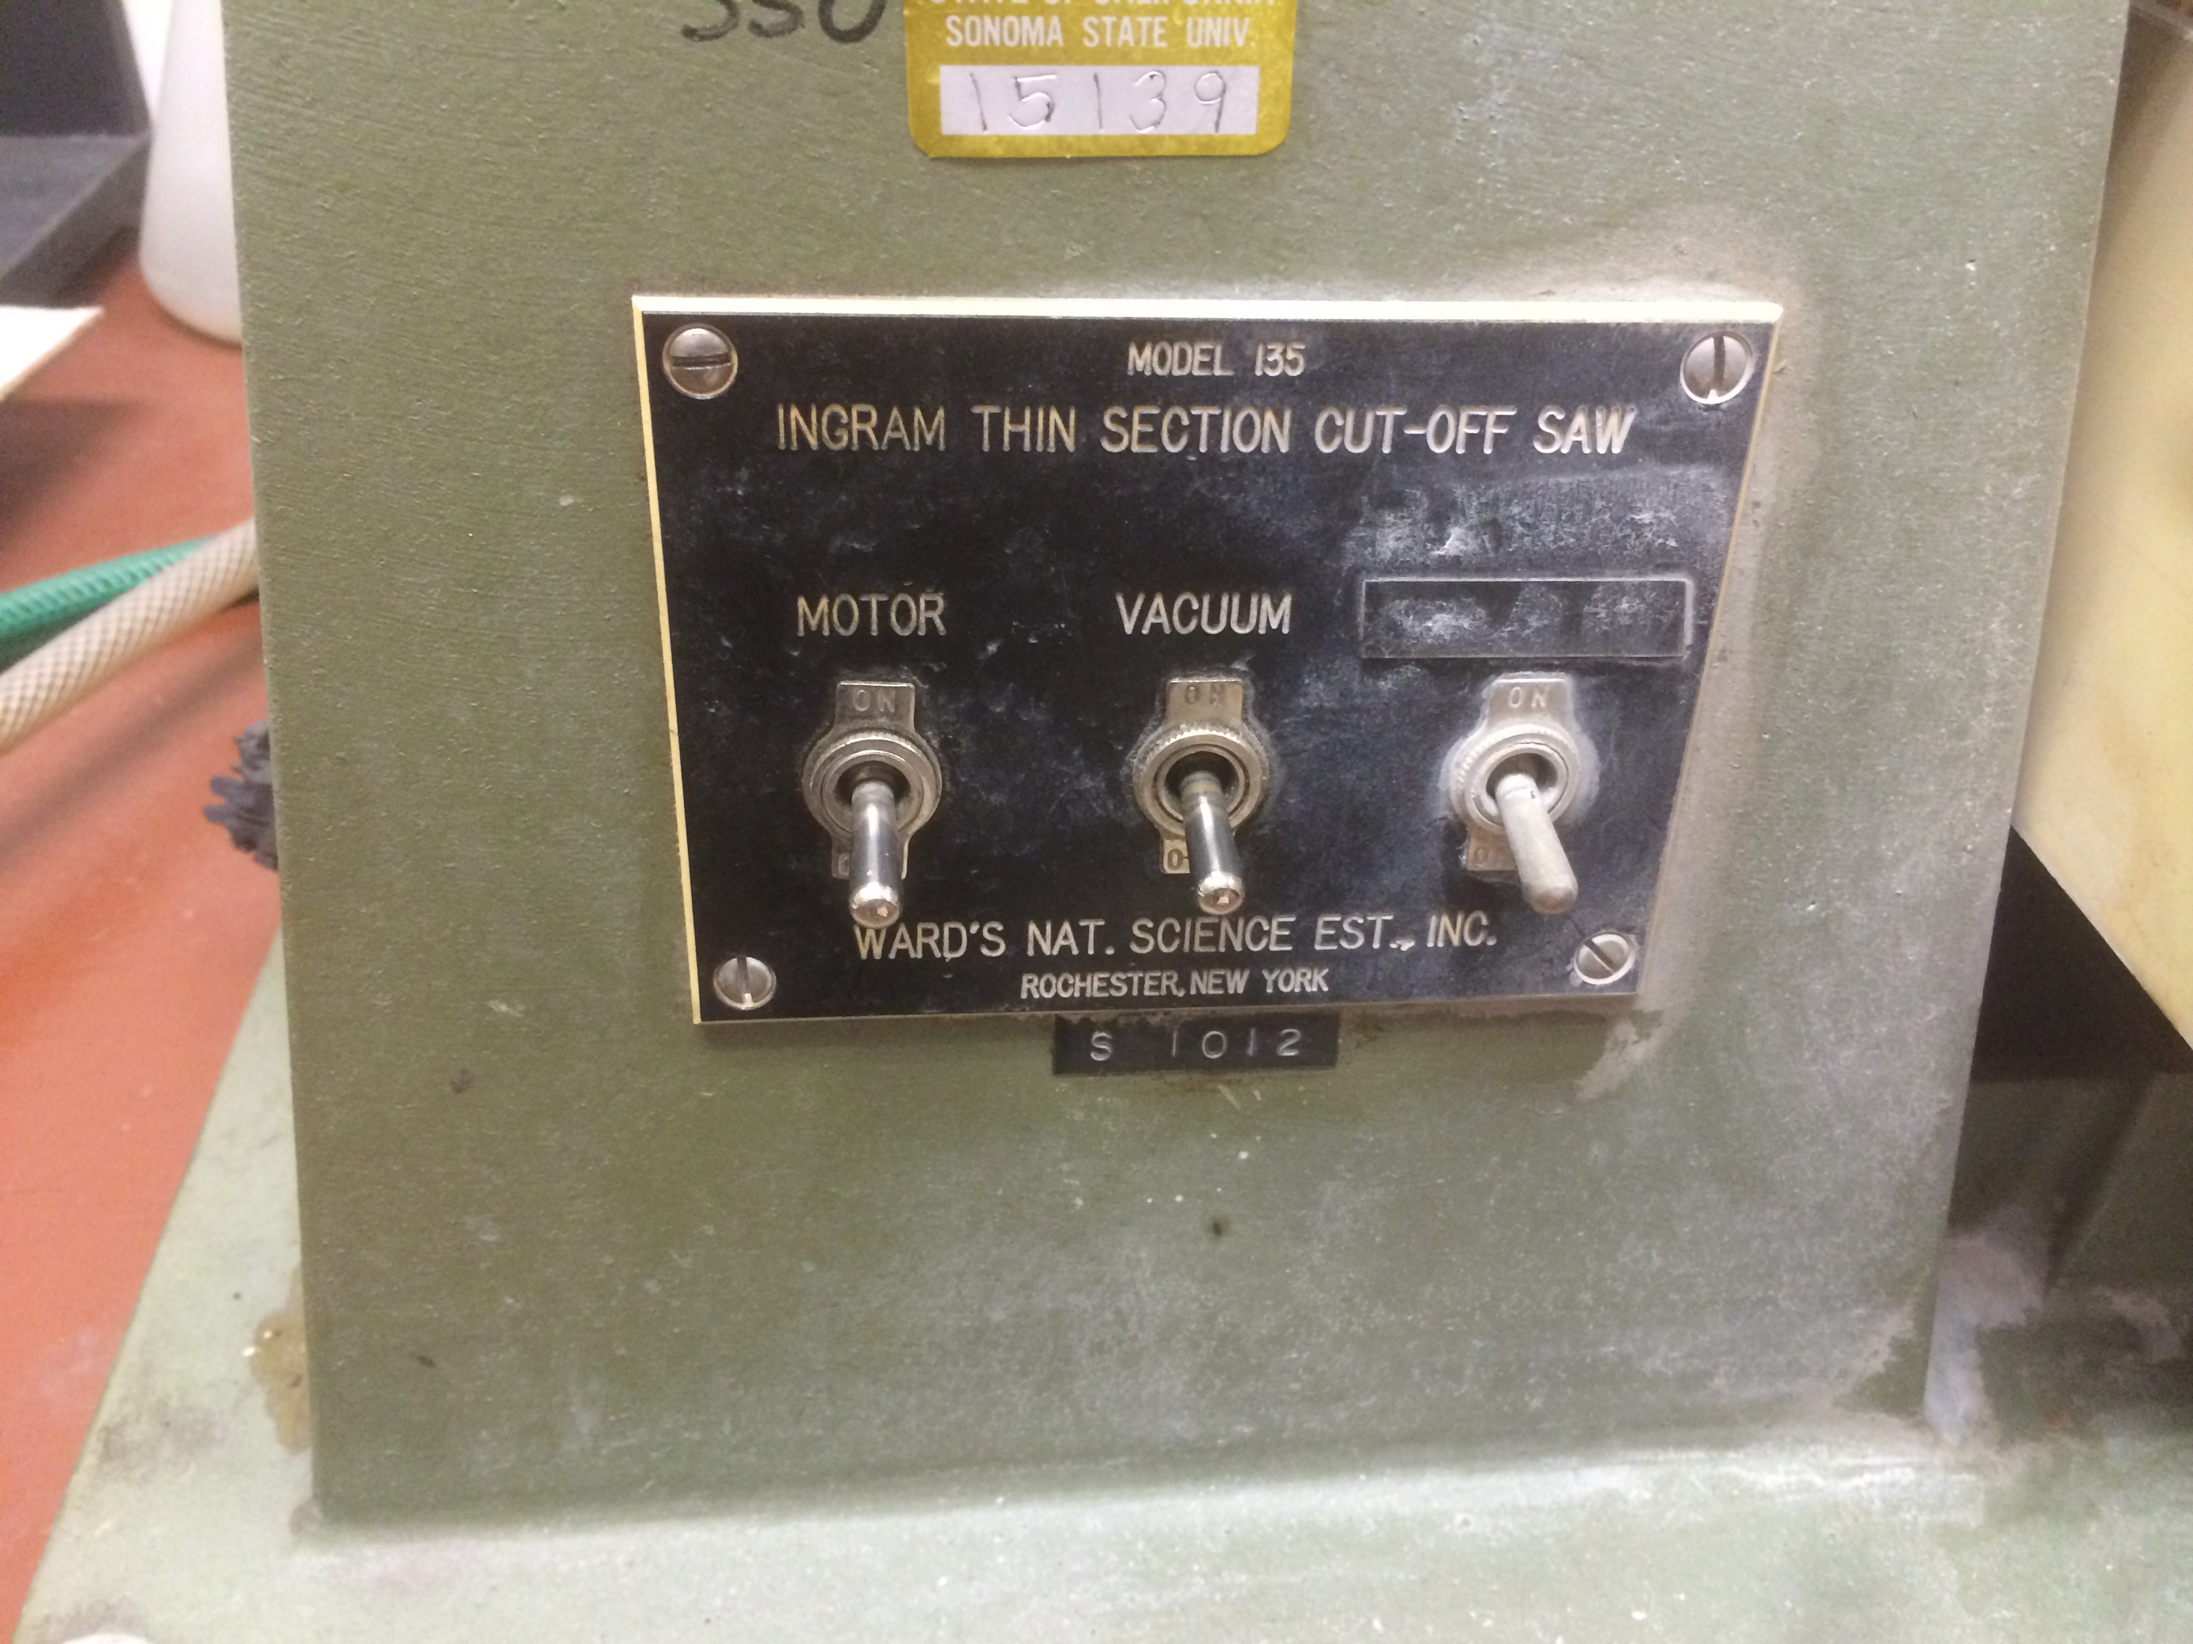
- Place clean glass slides over the vacuum holes on the trim saw. Then place thin section on the vacuum chuck face of the vertical grinder. This will create the vacuum that holds the slide.
- Turn on vacuum using the switch on the front of the trim machine to the left (Figure 18).
- Turn the fine rotation knob (the knob on the right-hand side of the grinder) counterclockwise to move sample away from grinding wheel (which is the zero point on the knob). Back off the sample enough so the sample doesn’t touch grinding wheel.
Figure 18 – Vacuum On/Off on trim saw
- Turn on motor using the switch on the front of the grinder.
- Swing arm back and forth. Advancing the carriage by turning clockwise with wheel at right end (Figure 19).
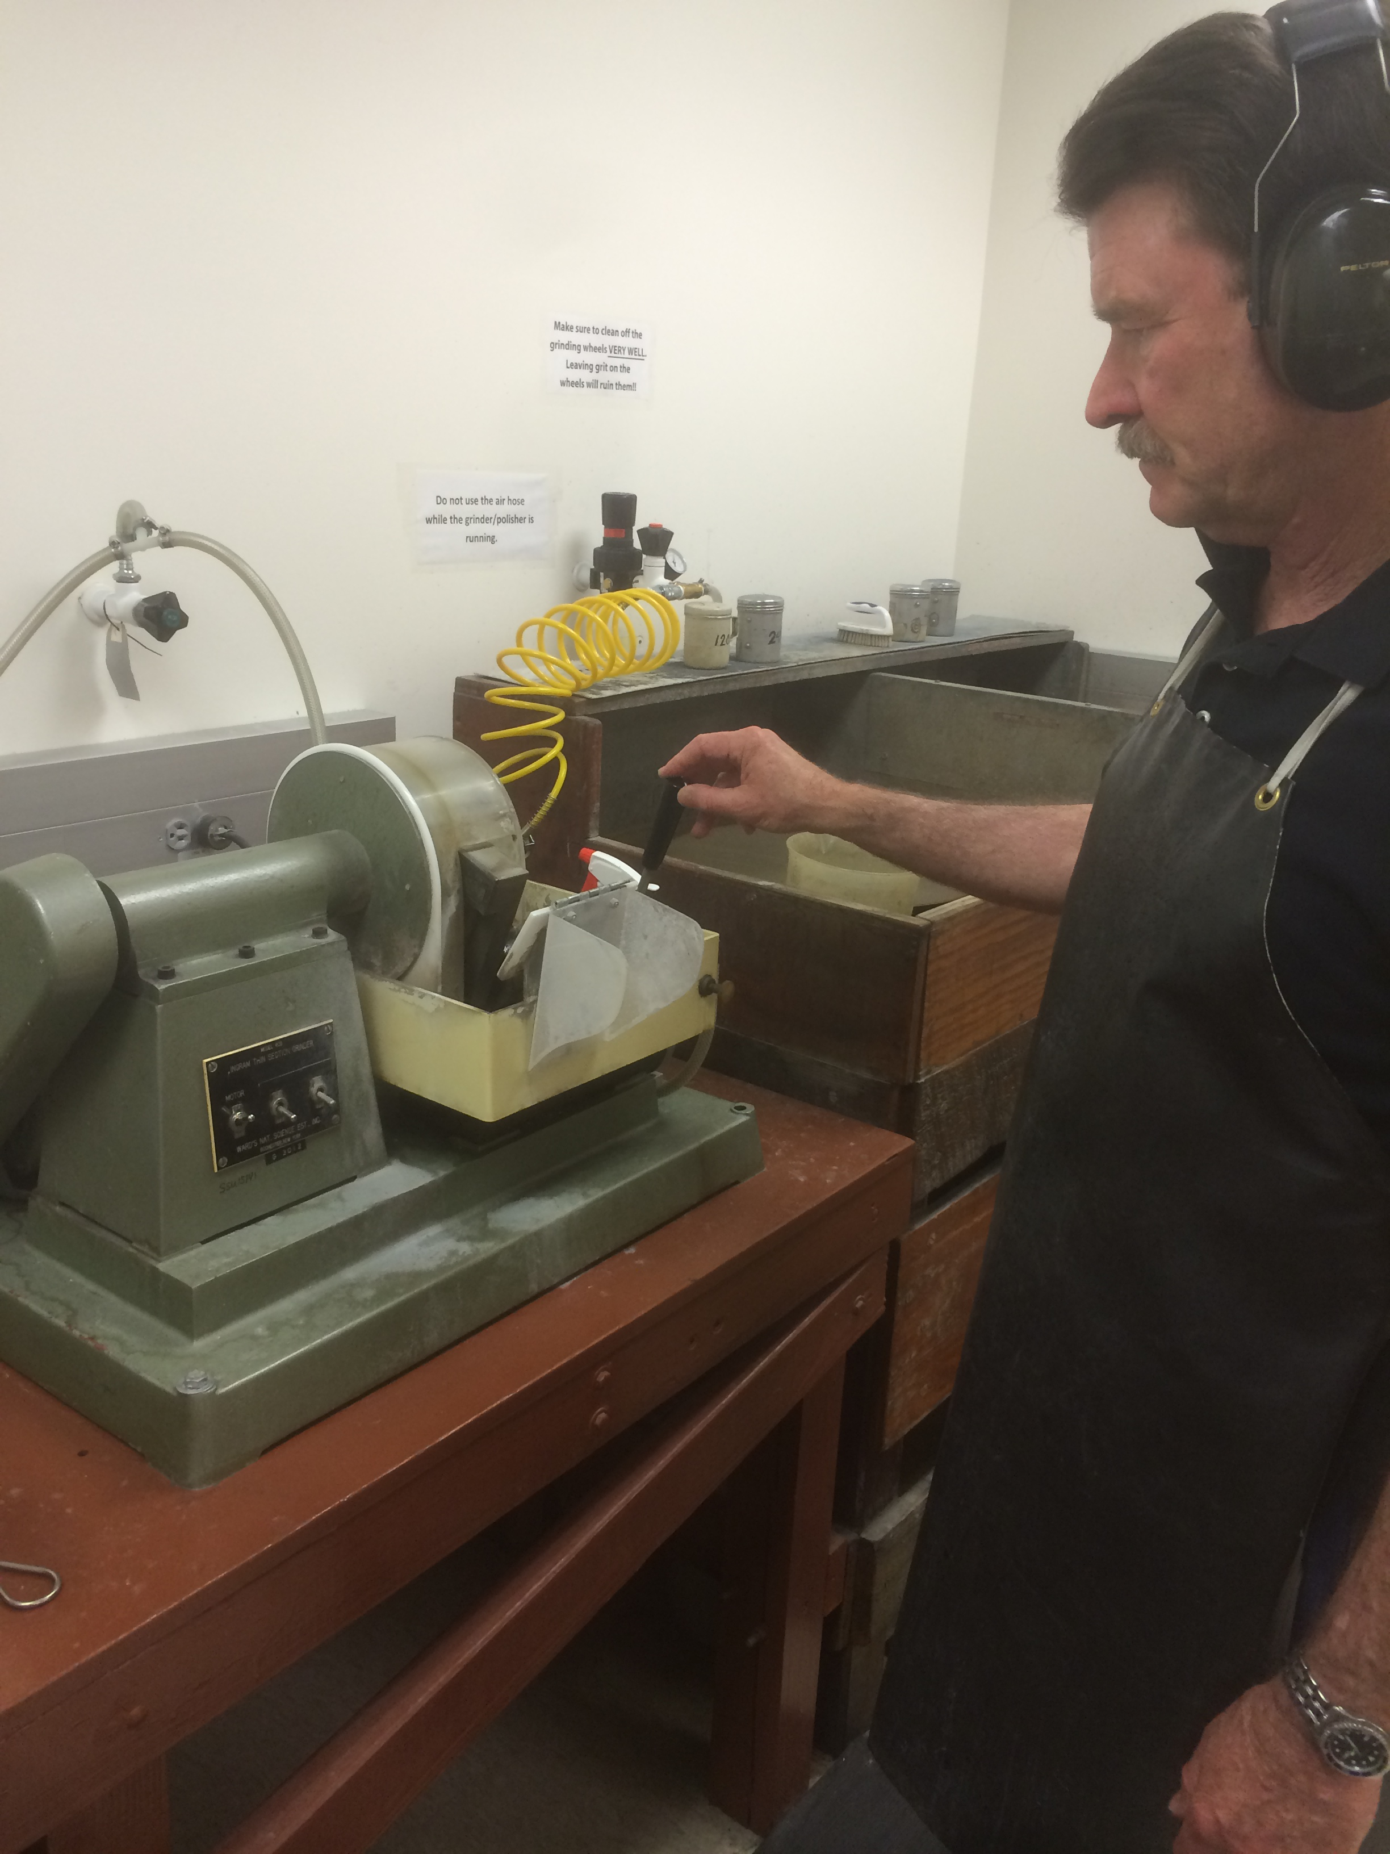
- Advance at a rate of 1/2 graduation at time. Swings the lever back and forth 2-4 times using a minimum force at each graduation. You will notice it’s hard the first time and then it gets easier. Do not create sparks. Go forward another ½ graduation and repeat.
Figure 19 – Grinder swing arm in motion
- Grind down until the swing arm advance wheel reads 29. The thin section should be come transparent and holes in the vacuum chuck can be seen through it. Remove the evolving thin section frequently and check thickness on the petrographic microscope. You can leave the machine running as you do this.
- Shut off water, vacuum, and grinder. Make sure the room and the equipment you have used is clean.

Finishing Thin Section and Installing Cover Slip

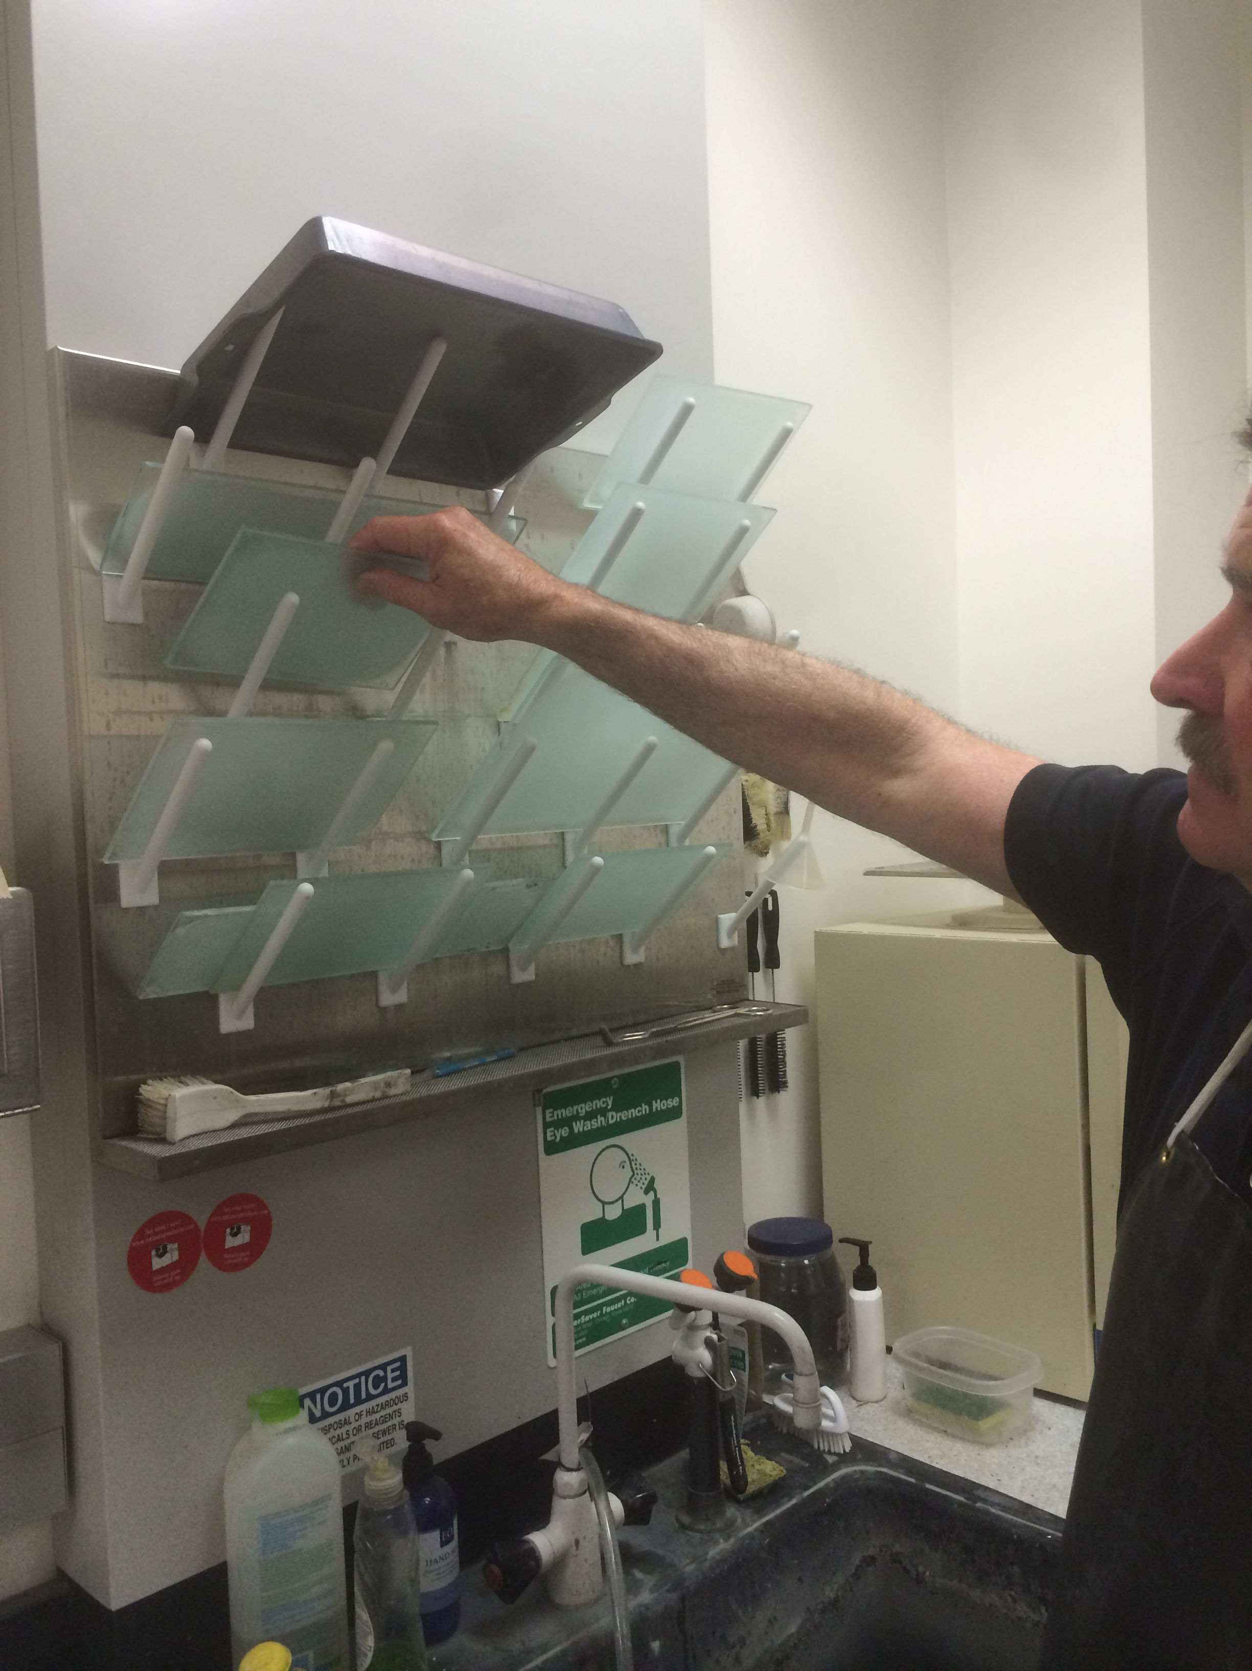
This is the final step of the process. In this step you will take your thin section and hand polish it to the correct thickness (30 um). If desired, attach a cover slip. This process can take up to 30 minutes.

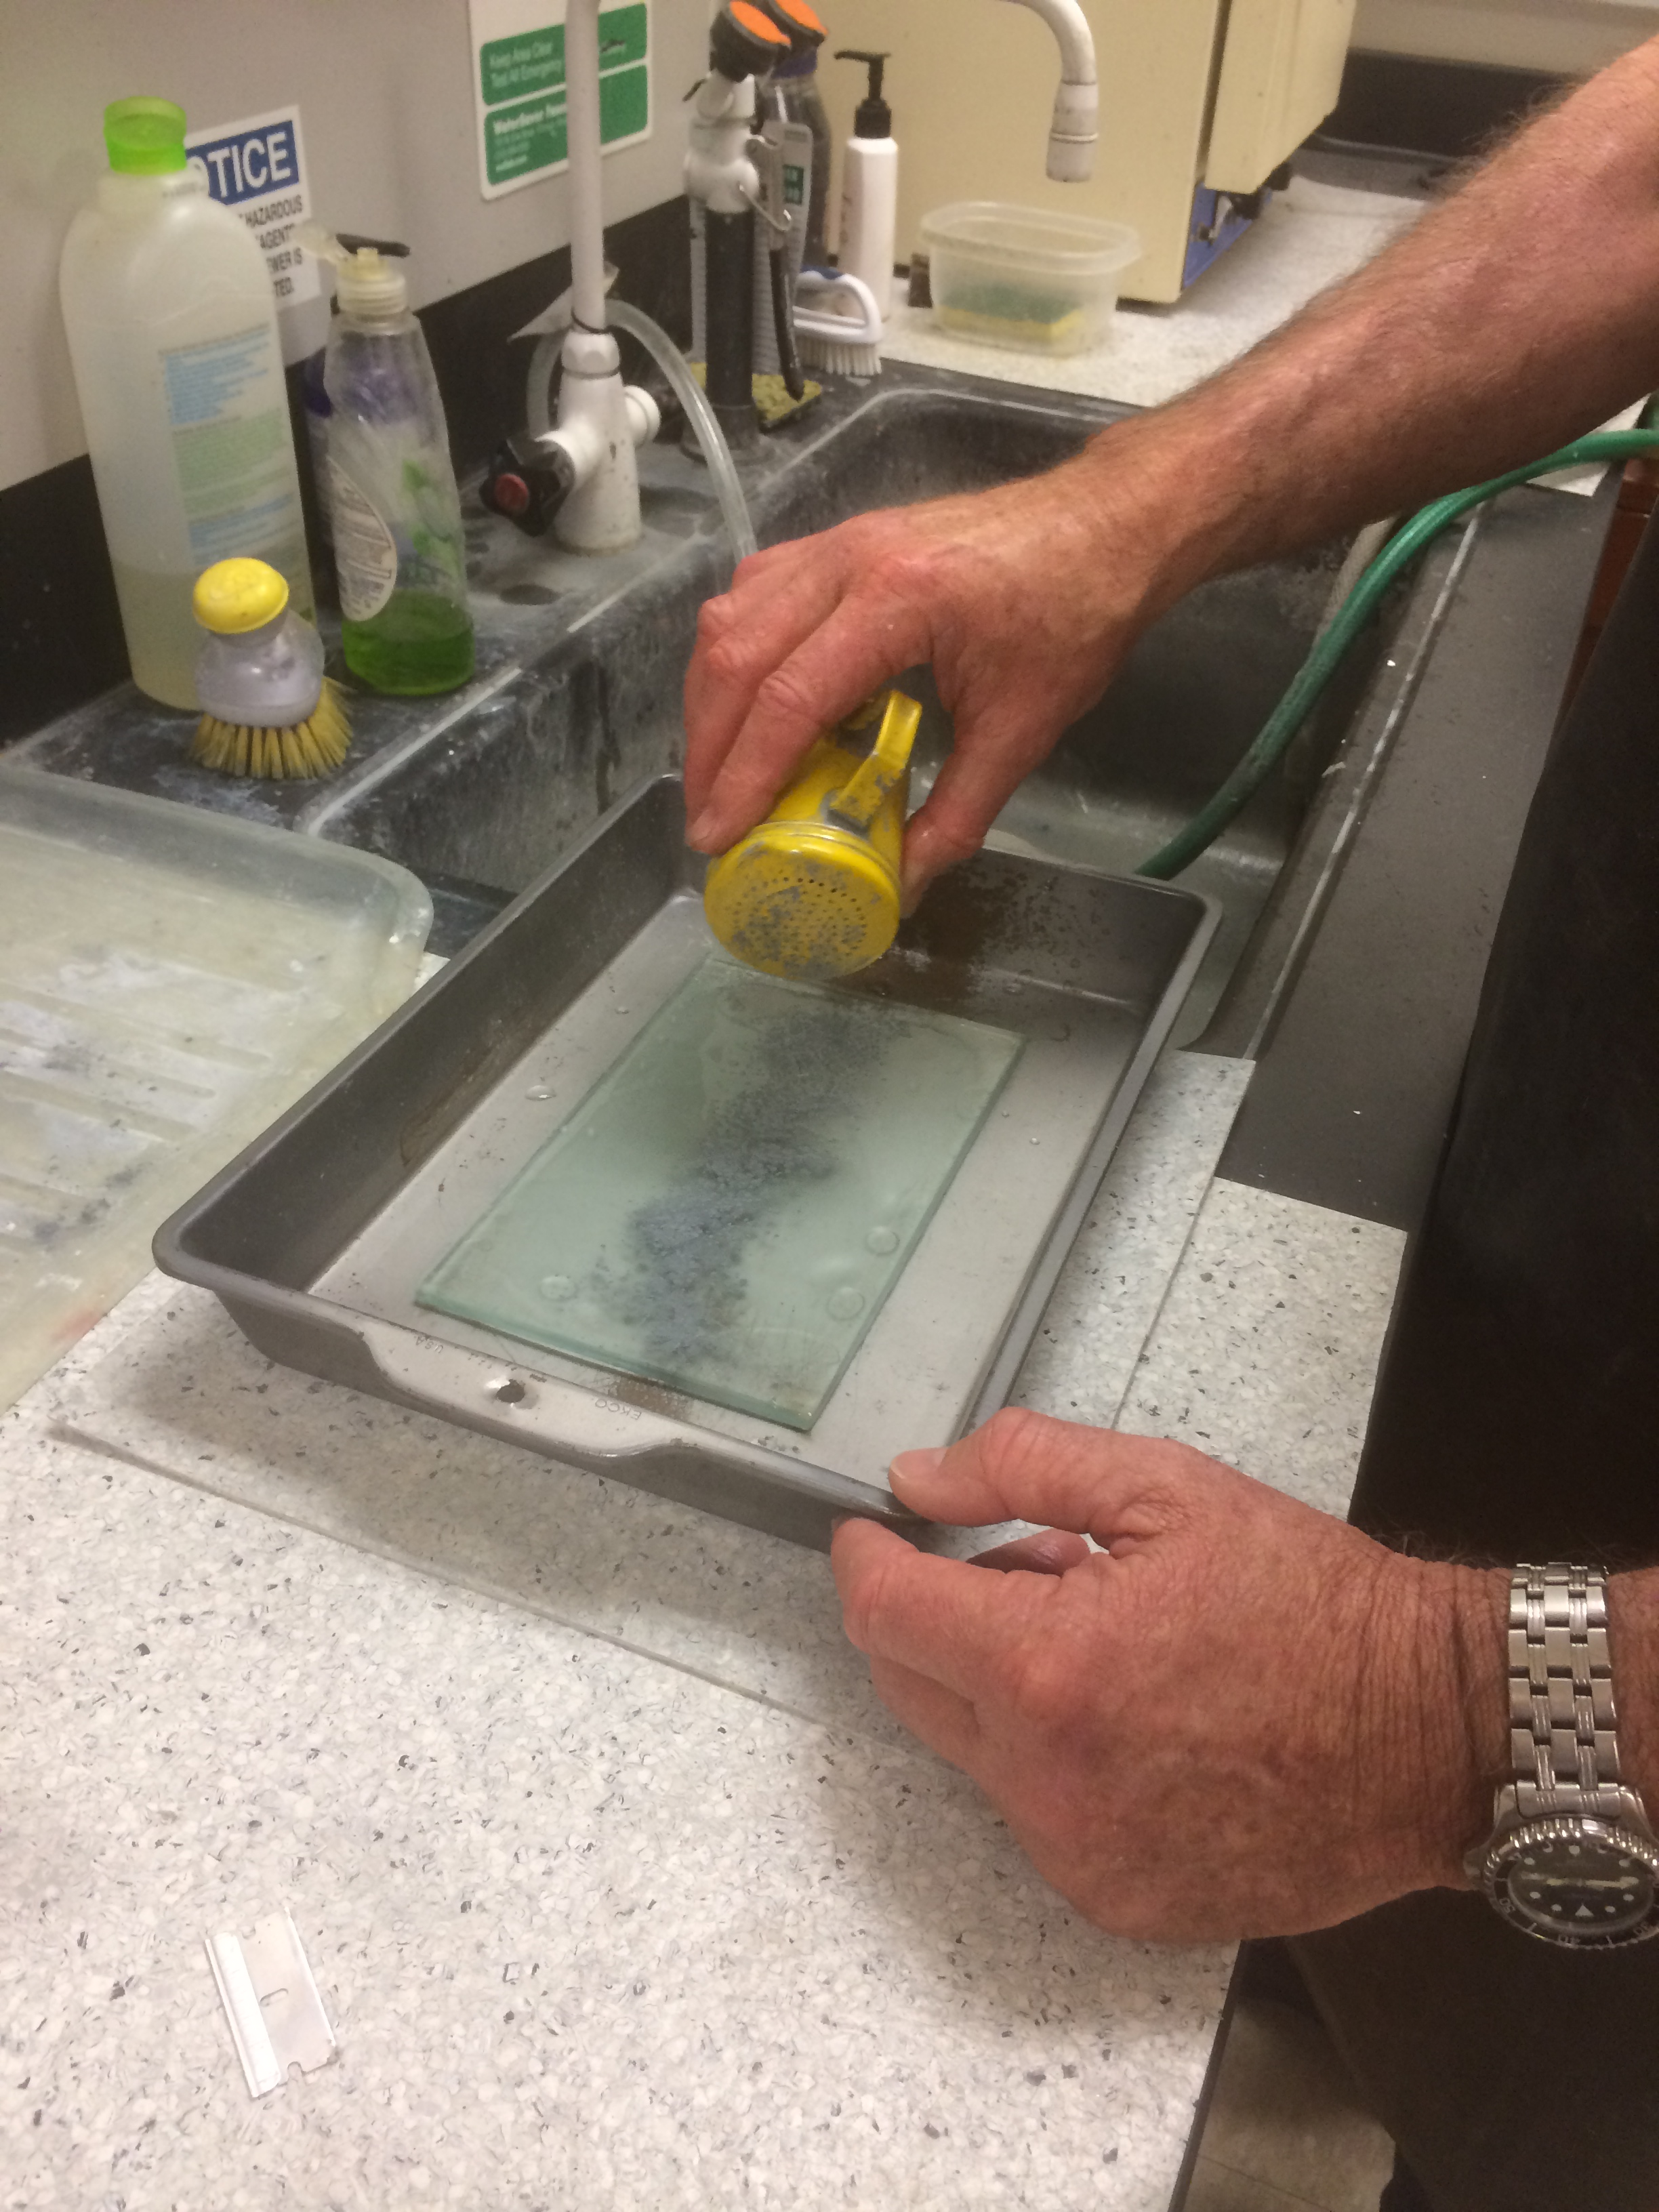
- Take down the aluminum cooking pan and place a flat piece of glass inside (Figure 20). Wet the glass on both sides and place 5 shakes (~1 teaspoon) of 600 grit on the glass plate. The grit is stored in the yellow shaker near the sink. Add a small amount of water to make a slurry (Figure 21).
Figure 20 – Glass polishing plates
Figure 21 – 600 grit slurry
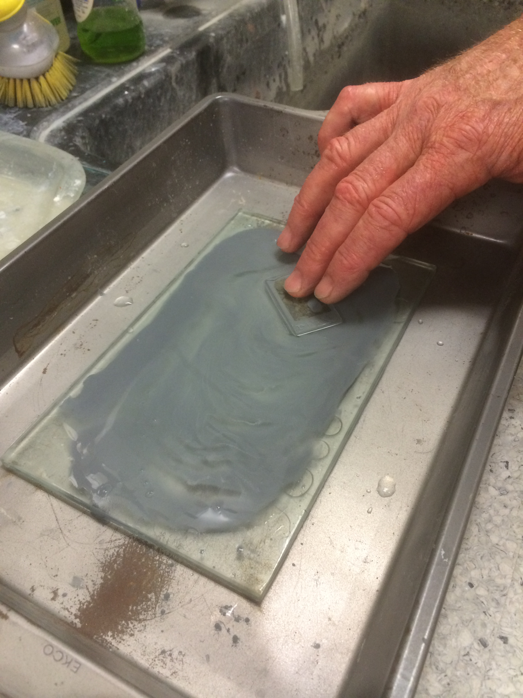
- Check with a microscope the thickness of the slide in different parts (it is likely that he middle is the thickest). Put the rock side of the thin section down into the slurry and move through with a figure-8 motion (Figure 22). It works well to place two fingers on the thin section and press the thin section evenly with only the weight of your hand. Rotate the section 180 degrees every minute to ensure a flat grinding. Remember the places where you press the hardest will be the areas that will grind away more quickly.
Figure 22 – Figure-8 grinding motion
- Rinse the thin section under water and check for thickness. Do this every few minutes at the beginning and continue checking more frequently as you get closer to the proper thickness.
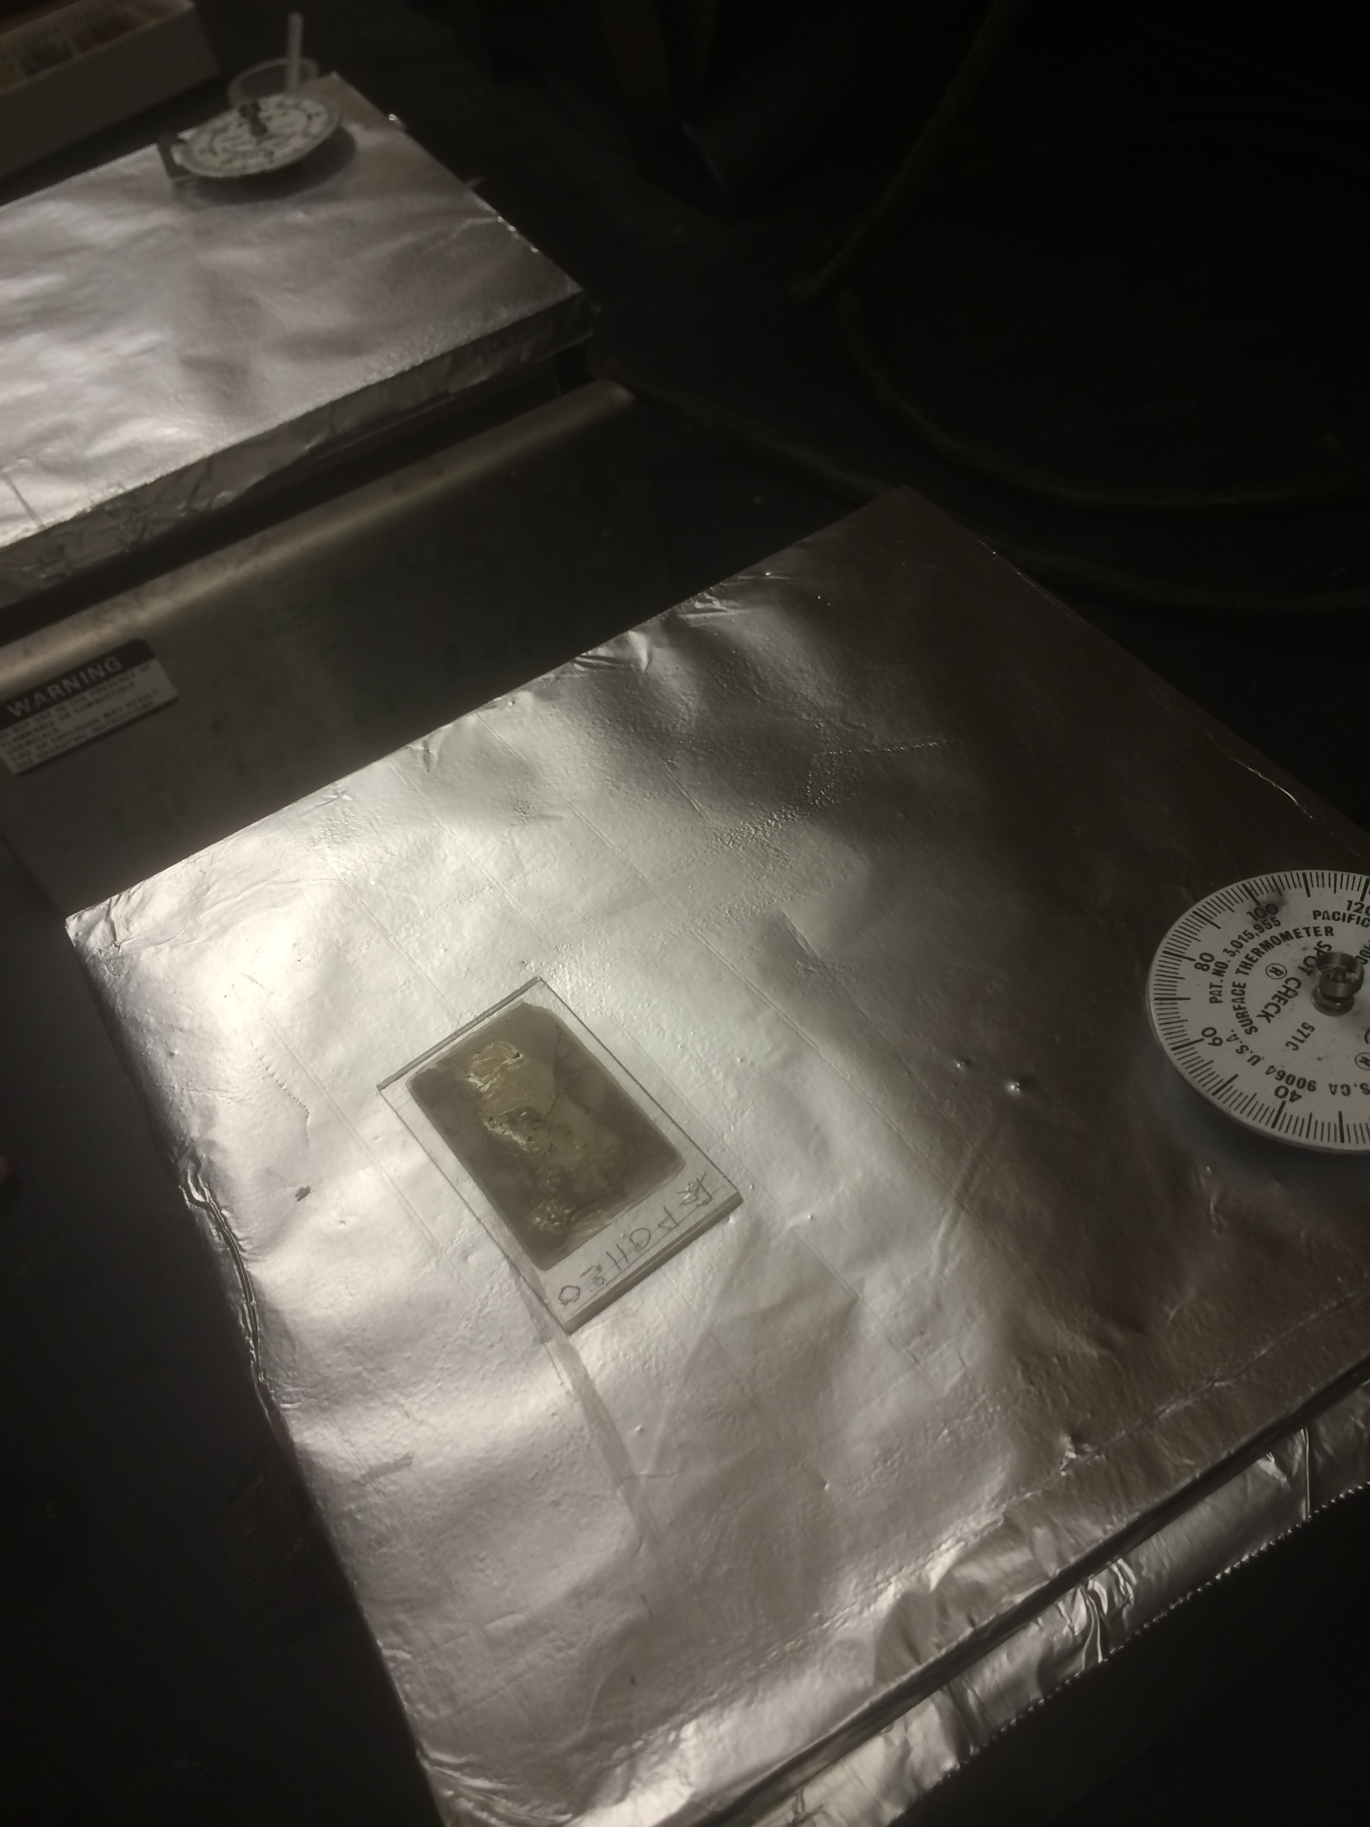
- Continue grinding until the section has reached a constant thickness and quartz has a first order grey to grey-yellow interference color. Use the chart on the wall behind the microscope to confirm the color.
- Dry the thin section on the hot plate for 5 minutes.
- Place a thin line of epoxy down the center of the thin section. Make sure to use a small amount of epoxy (Figure 23).
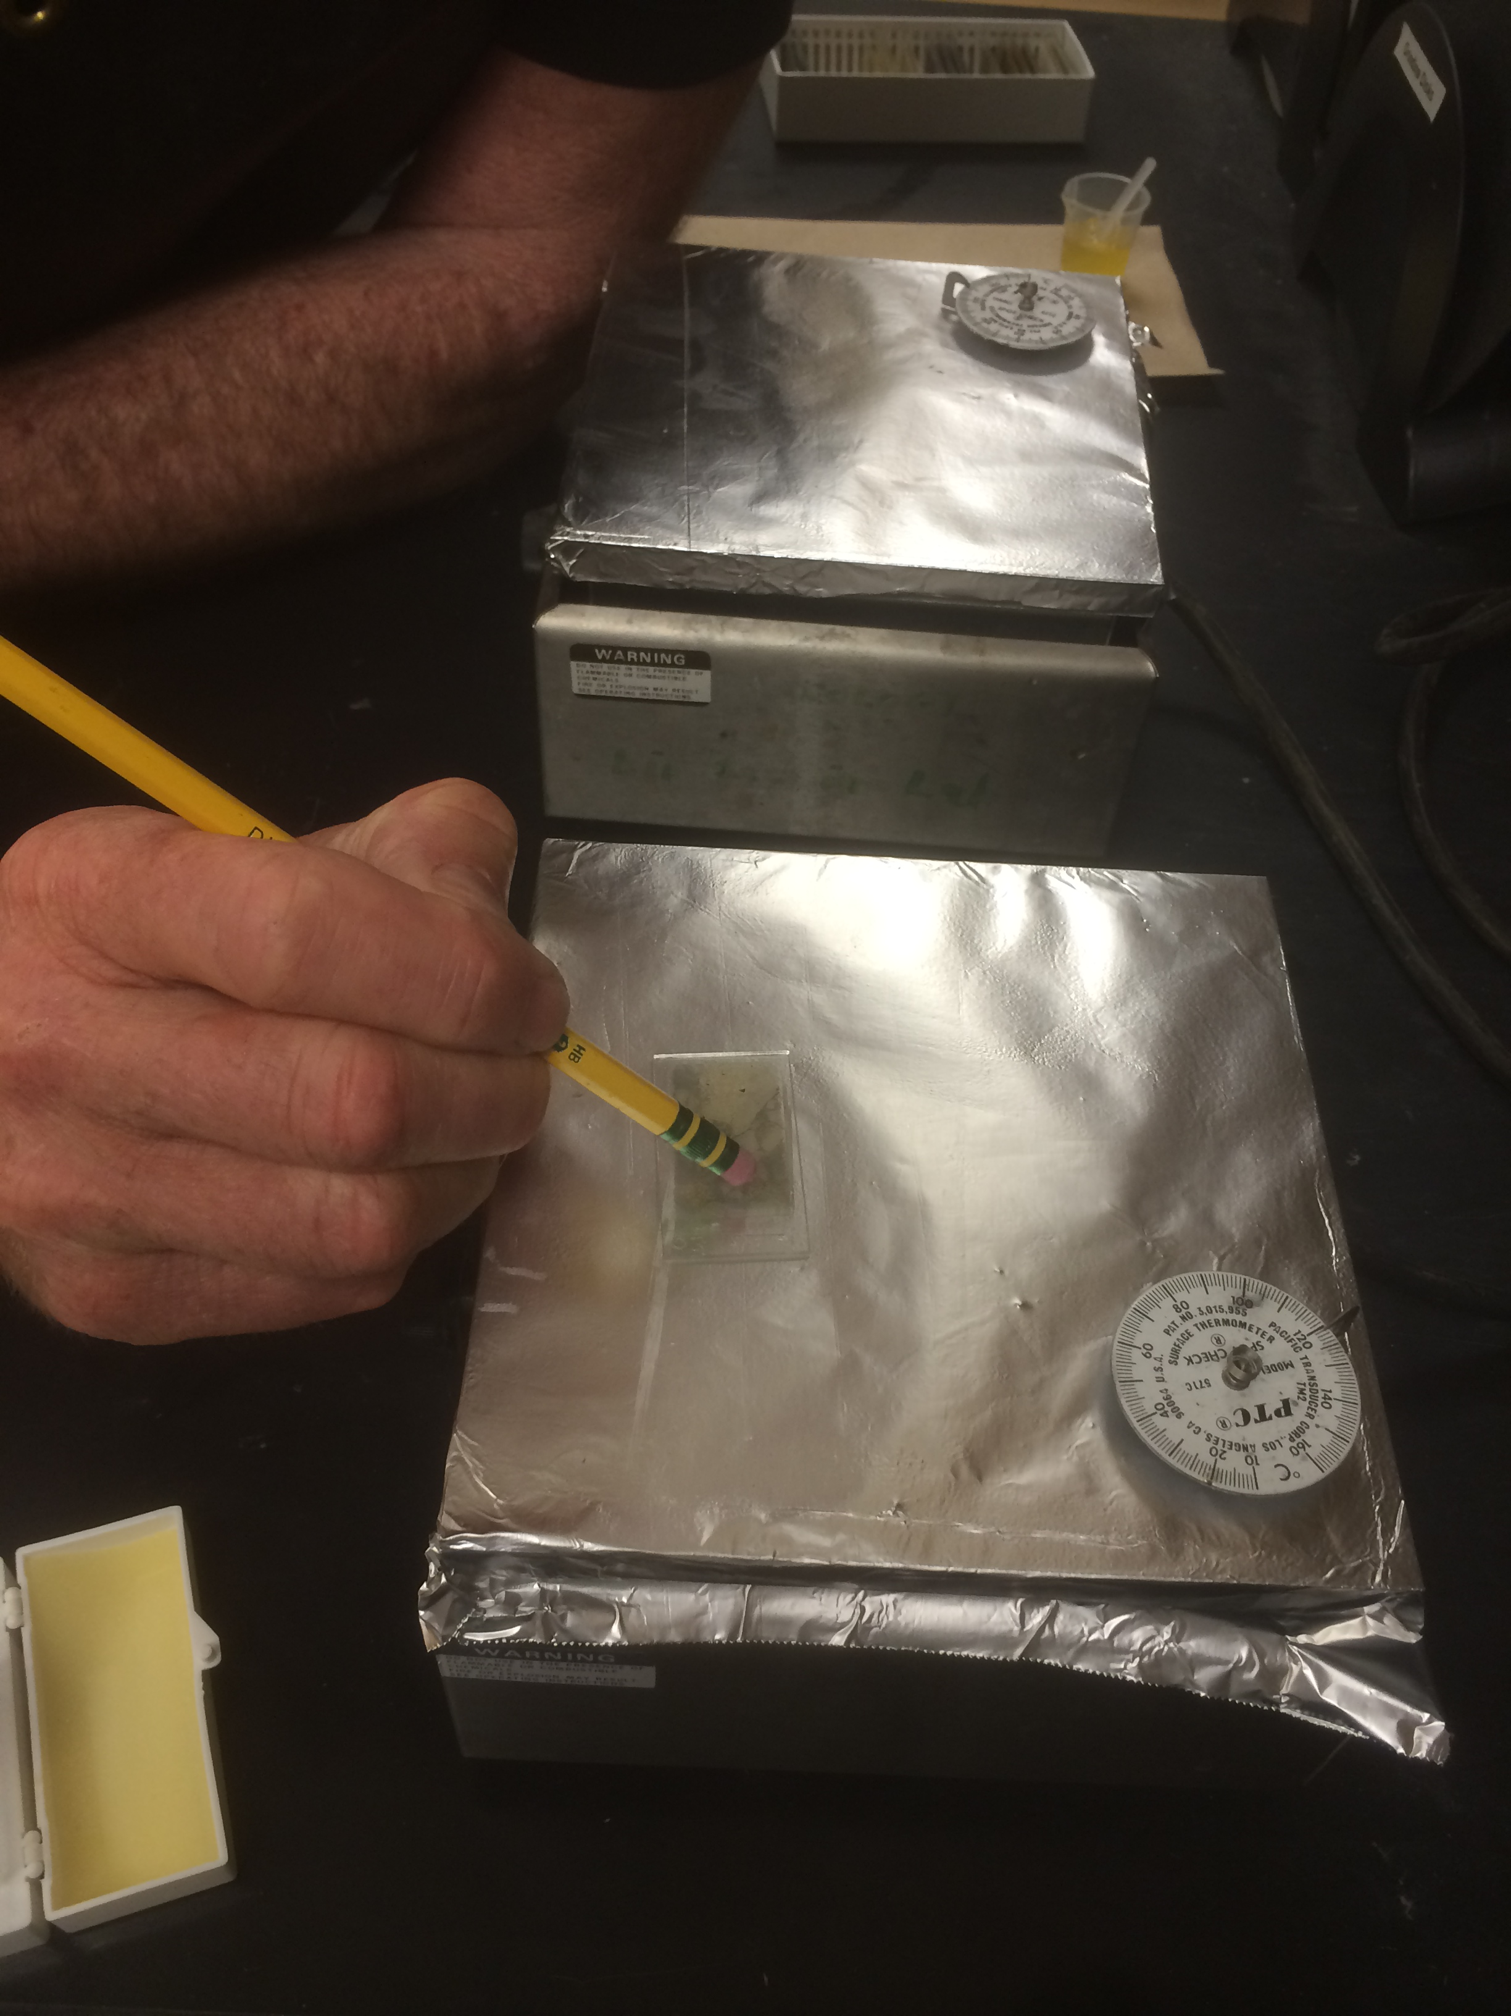
- Take a single cover slip (careful, they often stick together) and place onto thin section. Use a pencil eraser to gently slide around and remove bubbles (Figure 24). The cover slip is very thin and delicate, so make sure you are very careful not to crack the slip.
Figure 23 – Epoxy on cover slip
- Set on hot plate for 10-15 minutes. Take off hot plate and clean the lab.
- Congrats, you’re done!
Figure 24 – Using eraser to press on cover slip

